THE CIVIL SOCIETY ACTIVITY’S
EMERGING PRACTICES IN CAPACITY DEVELOPMENT IN THE CIVIL SOCIETY SECTOR
A Technical Document on the Strengthening of Civil Society in Mexico
JULY 2020

This white paper is part of a collection of strategic documents developed by the Civil Society Activity, implemented by Social Impact, Inc. and financed by the United States Agency for International Development (USAID). The texts that comprise the collection describe the systemic capacity development approach and methodology that the Civil Society Activity designed to accompany more than forty civil society organizations in institutional strengthening, grants management, and legal compliance. In particular, this document provides a detailed overview of the emerging best practices in capacity development that the Activity identified over the course of implementation, focusing on adaptive management, customized approaches, and sustainability. The full compendium is a useful resource for strengthening civil society organizations. You may reference the complete collection at Social Impact’s website, https://socialimpact.com/.

About the USAID Mexico Civil Society Activity
Mexico Civil Society Activity (CSA) was a 4-year program funded by the U.S. Agency for International Development (USAID). CSA aimed to improve the sustainability of Civil Society Organizations (CSOs) to effectively implement their agendas on violence prevention, human rights protection and justice reform in Mexico. To this end, CSA focused on improving CSOs’ capacity to communicate and work collaboratively, increasing their connections with key stakeholders, strengthening their capacity to develop strategies that respond to their changing environment and to their communities’ needs and priorities, and improving CSOs access to knowledge and resources.
The USAID Mexico Civil Society Activity was implemented by Social Impact (SI) Inc. in partnership with Fundación Appleseed.
About Social Impact
Social Impact (SI) is a management consulting firm that provides monitoring, evaluation, strategic planning, performance management and capacity building services to advance development effectiveness. SI’s work helps to reduce poverty, improve health and education, promote peace and democratic governance, foster economic growth, and protect the environment. To achieve this, SI delivers consulting, technical assistance, and training services to government agencies, nongovernmental organizations, and foundations.
Acknowledgements
The Civil Society Activity’s Guide to Scaling-Up Capacity Development through Transfer and Replication was developed through the collaboration of USAID, Social Impact, and the Civil Society Activity staff in Mexico. Funding for the Civil Society Activity’s transfer and replication of Capacity Development was provided by the United States Agency for International Development (USAID). Special thanks go to the following individuals who contributed to the conceptualization and content of this document, and/or reviewed and provided comments on the document: Elise Storck, Ireri Ablanedo, Gladys Rivera, Leonardo Escobar, and Lucila Serrano. Additional thanks go to CSA’s Capacity Development Team: Anne Largaespada, María Huerta, Mónica Corona, María Andrea Sanfeliz and Jessali Zarazua who provided direct support throughout the transfer and replication process. Additional support was provided by Mario Carmona and Nohemí Paredes.
Authors: Brandon Melecio Fischer and Elise Storck
Editors: Yolanda Talavera
This publication was produced for review by the United States Agency for International Development. It was prepared by the Civil Society Activity (CSA) for USAID Mexico Contract No. AID-OAA-I-13-00045. The authors’ views expressed in this publication do not necessarily reflect the views of the United States Agency for International Development or the United States Government.
Mexico City, 2020. All rights reserved by USAID or the U.S. Government. This document may be excerpted, photocopied, or adapted in whole or in part, provided the material is distributed free of charge and that credit is given to CSA and USAID.

CONTENTS
Introduction 4
I. The Civil Society Activity’s Approach to Capacity Development in Mexico 5
CSA’s Theory of Change 9
II. Putting Things into Perspective: The International and National Context 9
III. The Adaptive Management of Capacity Development 11
Communicating Capacity Development and Its Importance 12
Openness, Commitment and Investment 12
Structuring a Capacity Development Team 13
Transferring Capacity Development Knowledge and Skills to Multidisciplinary Experts 15
Managing Absorptive Capacities 17
Organizational Structure and Complexity 17
Organizational History and Size 19
Legal Status and Grants Administration 20
Decision-Making and Leadership Styles 21
Customized Approaches 24
Flexibility of Capacity Development Assessment Tools 25
Adaptive Management of the Replication of Capacity Development by Strengthening Organizations 28
IV. Conclusion 30
Systemic Impact 32
A Sustainable Model for Learning Communities 32
Study Tour Model 32
What Sustainability Means to the Civil Society Activity 32
APPENDIX 34
Appendix 1: CSA’s Training with Consultant-Specialists based on Collaborating, Learning and Adapting (CLA) 35

Introduction
For several decades, international cooperation agencies have directed their efforts towards building capacities in local and national actors in order to advance social development in a sustainable fashion. Among the sectors to which this support has been directed is organized civil society, which plays a crucial role in improving access to fundamental social services, protections and rights. This white paper documents the experience of USAID/Mexico’s Civil Society Activity (CSA), which strengthened the capacities of a cohort of forty-five organizations working in areas of human rights, crime prevention, and justice reform in Mexico between 2016 and 2020. By design, the Program used a systemic approach to capacity building by focusing not only on refining internal capacities, but also on improving organizational performance and strengthening the sector as a whole. By systematizing CSA’s methods, experience and challenges during implementation, as well as lessons learned, this document is intended to inform the design, execution and close-out of similar capacity development projects being implemented around the world, and particularly in Latin America.
The document draws upon numerous sources of evidence gathered during CSA’s four years of implementation in areas of institutional strengthening, grants management and legal support. It is structured to systematize and transfer knowledge in a way that permits the practical application of emerging practices that the Activity identified based on lessons learned. The opening section describes the evolution of CSA’s approach as well as the methodologies that the Activity designed and implemented. The following section outlines the principle of adaptive management, which CSA adopted throughout implementation in order to coordinate a wide range of complex processes simultaneously and in a flexible fashion with organizations based on their needs and constraints. Within adaptive management, the document addresses the measures that CSA took to achieve customized approaches and the sustainability of results in capacity development. Each of these sections highlights concrete and actionable emerging practices that other development practitioners can adopt, implement and adapt according to their given context and stakeholders. The document closes with a summary of key emerging practices in capacity development.
The primary audience for this document is comprised of actors who carry out capacity development and those who receive capacity development support. Donors, implementing partners and strengthening organizations can consult the lessons learned to design, implement and adapt their own capacity development approach, building upon CSA’s experience to create an approach that makes sense given the context. Organizations that seek capacity development services can turn to the lessons learned to understand what goes into capacity development and better define the type of support they need. We believe CSA’s lessons learned have value as emerging practices that others can apply and replicate, adapt and refine based on their own operating environment. Of course, CSA’s experience has been shaped by the context and location of its own implementation, meaning that the guidance provided may be more relevant to the Latin American context. Practitioners who adopt and adapt the emerging practices outlined here are encouraged to document and share their own experience to continue to promote learning.
Each section in this document ends with a list of the key emerging practices that correspond to CSA’s lessons learned for the purposes of easy reference.
It is key to note that this document is the product of extensive application of Collaborating, Learning and Adapting (CLA) in which its content resulted from diverse participatory processes involving CSA staff, consultants, subcontractors and partner organizations. For example, over the course of the Activity’s four years of implementation, more than twenty consultant experts participated in a series of workshops to share and document emerging practices during the implementation of performance solutions to inform future interventions. These were generative spaces in which consultants and staff developed new ideas of how to carry out capacity development interventions. In addition to these workshops with consultants, focus groups involving CSA staff served as creative spaces to pause, reflect and systematize lessons learned. The participatory processes that went into drafting this document mirror CSA’s capacity development approach, together supporting the continuous improvement of the Activity’s implementation based on evidence that can now be shared with others.

I. The Civil Society Activity’s Approach to Capacity Development in Mexico
USAID/Mexico designed the Civil Society Activity (CSA) to improve institutional capacities and increase the sustainability of civil society organizations (CSOs) in Mexico so they can more effectively implement their agendas related to crime and violence prevention, legal justice reform, and human rights. CSA supported three of USAID/Mexico’s Development Objectives: DO 1 on crime and violence prevention; DO 2 on access to justice; and DO 3 on human rights. Social Impact, a development management consulting firm based in Arlington, VA, was the prime implementer of the CSA contract and designed the approaches described in this Strategy based on close collaboration with local partner organizations.
CSA’s strategic approach remained firmly rooted in the original capacity-building purpose; upon receiving a contract modification on June 22nd, 2018, CSA expanded its interventions to emphasize systems-based strengthening, in addition to internal organizational capacity development, to sustain development results. With an emphasis on improved organizational performance, rigorous assessment, the co-creation of solutions, systemic impact, and sustainability, CSA’s comprehensive approach was well aligned with USAID’s Journey to Self-Reliance (J2SR) and focus on measurable, increased local capacity. Thus, CSA provides a potential model for other USAID-funded capacity-building activities, as well as other capacity-building work, to enhance development impact and sustainability. Figure highlights the three dimensions of CSA’s Strategy.
Figure 1. CSA’s Strategy for Sustainability of Results
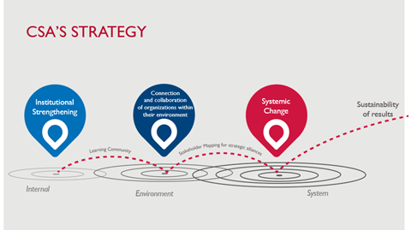
CSA’s systemic approach to capacity development had three primary components:
GRANTS: Award and administer USAID grants to civil society organizations to help them develop their thematic projects and capacity development initiatives.
LEGAL STRENGTHENING: Provide technical support to improve legal compliance in areas of corporate, fiscal, and labor law; money laundering; and data privacy, through a network of pro-bono law firms based in Mexico, coordinated by CSA.
INSTITUTIONAL STRENGTHENING: Accompany SOs in developing their capacities in three ways—by improving internal capacities, strengthening abilities to create and sustain strategic alliances, and solidifying their positions within their Local Systems—based on an integrated methodology that incorporates Human and Institutional Capacity Development (HICD), Local Systems and Capacity 2.0 approaches.
CSA worked with three groups of civil society organizations (CSOs), categorized in Tiers:
TIER 1: Ten CSOs that were awarded a USAID grant during Year 1. Three of these CSOs are Intermediate Support Organizations (ISOs)iv that replicated grants administration and capacity development with 14 CSO subgrantees. Organizations in this Tier received CSA’s full range of technical assistance.
TIER 2: Fourteen CSOs that were introduced to CSA by USAID/Mexico and its implementing partners. Tier 2 organizations took part in a modular assessment of organizational performance based in USAID’s Organizational Capacity Assessment (OCA), the Organizational Performance Index (OPI), Social Network Analysis (SNA), and Stakeholder Mapping. Tier 2 organizations then received technical assistance to improve their legal status and performance solutions to address performance gaps identified during the assessment process.
TIER 3: CSOs and actors who are influencers in the civil society sector. The influencers will sustain CSA’s legacy in strengthening the Local System by leveraging their own areas of expertise to benefit civil society actors and their ability to collaborate within the system. These key influencers include innovators, whether they be leaders of change, intermediaries across sectors, or key sources of information for the civil society sector.
Figure 2 provides an overview of the expanded vision that the Civil Society Activity incorporated to achieve a systemic impact in supporting each of the three Tiers.

Figure 2. Evolution of the Civil Society Activity
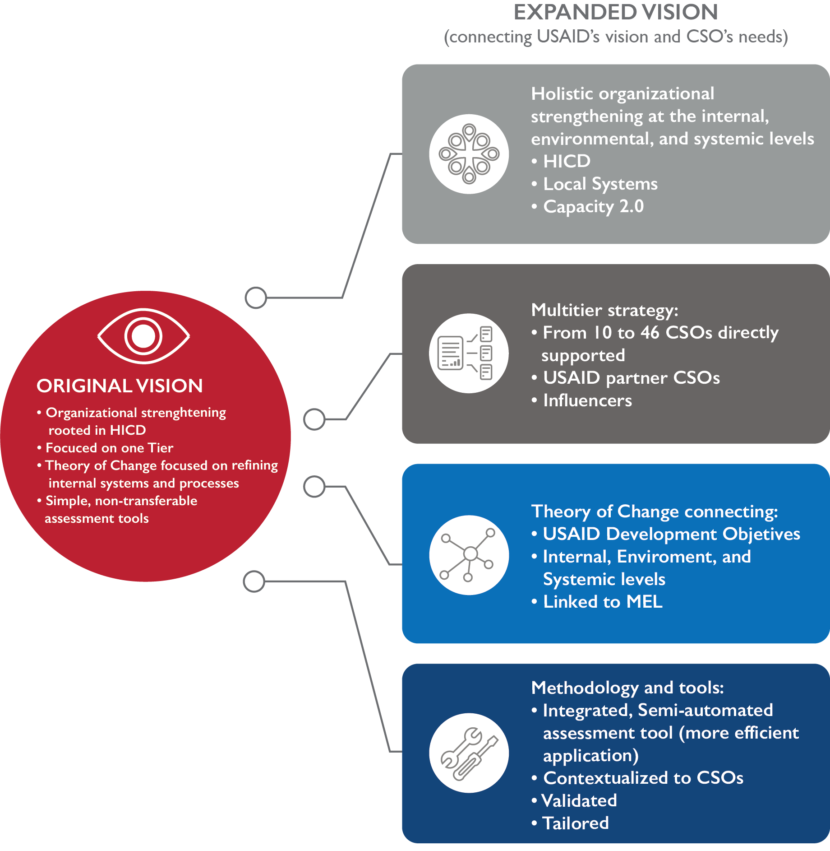
Social Impact based CSA’s original design on the HICD model. However, as CSA became familiar with Capacity 2.0 at USAID and held pause and reflect sessions with partner organizations, CSA determined a need to expand its capacity development approach. Consistent with Collaborating, Learning, and Adapting, the CSA team proposed additional components to the theory of change that would complement the original HICD design, while also drawing upon the latest best practices in the field. Aligned with the Local Systems and Capacity Development 2.0 approaches, CSA began to view organizational strengthening in three dimensions: strengthening internal capacities; strengthening relationships and networks in which organizations participate; and strengthening organizations’ positions within their Local Systems.
In a major conceptual and methodological shift, CSA expanded its approach to capacity development by adopting USAID’s Local Systems framework. Based on this framework, CSA views each CSO as one of many actors within a system working around a given social issue. For individual CSOs and the CSO sector to have sustainable impact, it is crucial to develop their organizational capacities to interact, communicate, and collaborate, including with other diverse actors operating in the same system. In this way, CSA could more effectively support organizations as they tackled complex challenges in their environments.

CSA’s Theory of Change
CSA’s revised theory of change was rooted in a holistic approach that incorporates USAID’s Human Institutional Capacity Development, Capacity Development 2.0, and local systems approaches as follows:
“If CSA works to build the internal and external capacity of local CSOs and the connections between CSOs and key stakeholders, then CSA will contribute to the sustainability of the civil society sector and effective local programming to address crime and violence prevention, human rights protection, justice reform and transparency.”
CSA assumed that organizations exist within systems that affect their performance as much as organizational performance can directly affect the broader system. For this reason, the CSA team found it important to establish a theory of change that focused both on internal and external performance factors, thereby supporting performance improvement and the sustainability of results within the civil society sector in a way that leveraged the individual characteristics and systemic contributions of each organization CSA supported. Driven by this commitment to a capacity building approach that far exceeds the internal strengthening of organizations, CSA’s theory of change aimed to more comprehensively support the civil society sector in Mexico as it moves toward self-reliance and contributes to the achievement of USAID/Mexico’s Development Objectives (DOs).
Before describing the emerging practices that CSA identified during implementation, it is important to situate CSA’s international and national context between 2016 and 2020.

II. Putting Things into Perspective: The International and National Context
Internationally, analysts and experts from institutions such as the Carnegie Endowment for International Peace, CIVICUS, the International Center for Not-for-profit Law (ICNL) and Open Democracy have highlighted the reduction of civic space beginning in 2016. According to these sources, the shrinking of civic space is, in part, the result of domestic pressures such as national leaders that stifle civic activity to advance personal or nationalist interests, although this is not the entire story. International trends have also contributed to reduced civic space, including privatization, outsourcing, the influence of transnational actors with vested interests, and the promotion of policies that draw resources away from public services under the banner of austerity. Given the threat of unilateral government action, the ICNL and other actors have urged that fundamental rights and freedoms and civic space be protected. Furthermore, beginning in early 2020, the COVID-19 pandemic took hold of global societies and economies, bringing still more challenges to civil society actors.
Within the national environment, marked shifts in the political climate also had a direct effect on the civil society sector in Mexico during CSA’s implementation. In the second half of 2018, more than 3,400 elected officials took office at all levels of the Mexican government. This led to a major reconfiguration of power in the country and presented both challenges and opportunities for the civil society sector. Organizations working in collaboration with the Government of Mexico (GoM) and those active in advocacy had to establish new relationships based on trust with local, state and federal authorities and legislators, as well as other public officials who entered office. At the federal level, the new administration began implementing or signaled the intent to implement significant shifts in public policy, including in areas of interest for USAID such as human rights, access to justice, crime prevention and transparency. Examples include the creation of the National Guard, the new National Law on the Use of Force published in May 2019, and the Constitutional reform that expanded the types of crimes that merit pre-trial detention.
For CSA, the GoM measures that had the greatest impact on the civil society sector concerned public funds and the fiscal policies to which CSOs are subject. In mid-February 2019, the President issued a memorandum directing all federal government agencies to indefinitely suspend all social programs that provided public funding to CSOs. As of the time this document was written in August 2020, this suspension is still in effect. This presidential decree has raised legitimate concerns about the financial sustainability of organizations that provide vital social services that are seldom funded by private donors. CSOs also expressed concerns about the new government’s decision not to renew a prior presidential decree that allows CSOs to obtain tax-exempt earnings from the sale of goods and services. This, according to some experts, generates legal uncertainty for CSOs who are seeking to comply with fiscal obligations and could ultimately compromise their sustainability.
Moreover, the complexity of Mexico’s legal framework presents a significant challenge for CSOs to remain compliant for several reasons. To begin, compliance with regulations can be costly and burdensome. Also, gaps and contradictions in the legal framework leave ample room for discretional interpretation by authorities. Finally, organizations find it difficult to obtain proper legal advice and are often unaware of their obligations. (Huerta, Ablanedo & Vázquez, 2017) Broadly speaking, the legal framework that regulates Mexican CSOs is rife with contradictions and loopholes.
Specific aspects of the regulatory framework create particular hardship. This is the case with the “authorized donee” status, which provides income tax exemptions to organizations and allows them to issue tax-deductible receipts to their donors. Authorized donees have legal restrictions on their sources of funding, whereby no more that 10% of their income can be generated by activities that differ from their main social purpose and no more than 5% of donations can be used on administrative expenses, which are not clearly defined in the law. Failure to comply with the discretionary interpretation of the law can cost organizations this important “authorized donee” status, increasing their financial vulnerability.
In addition to the impact of the government and its legal and regulatory framework on civil society, Mexican CSOs have historically maintained a culture of distrust and competition rather than collaboration. In part, this culture of competition is the result of CSOs vying for the same pool of scarce resources from local, regional and international donors, which has tended to inhibit the exchange of information and collaboration. Organizations working in the same thematic areas also feel the pressure to assert that their model of intervention produces the most impact. Regardless of the reasons, however, the failure of CSOs to collaborate, exchange information and share resources has inhibited the ability of Mexico’s third sector to gain visibility and sustain the results that it achieves over time.
Figure 3 provides information on the national and international environment in which CSA carried out its implementation.
Figure 3. The Mexican and International Context
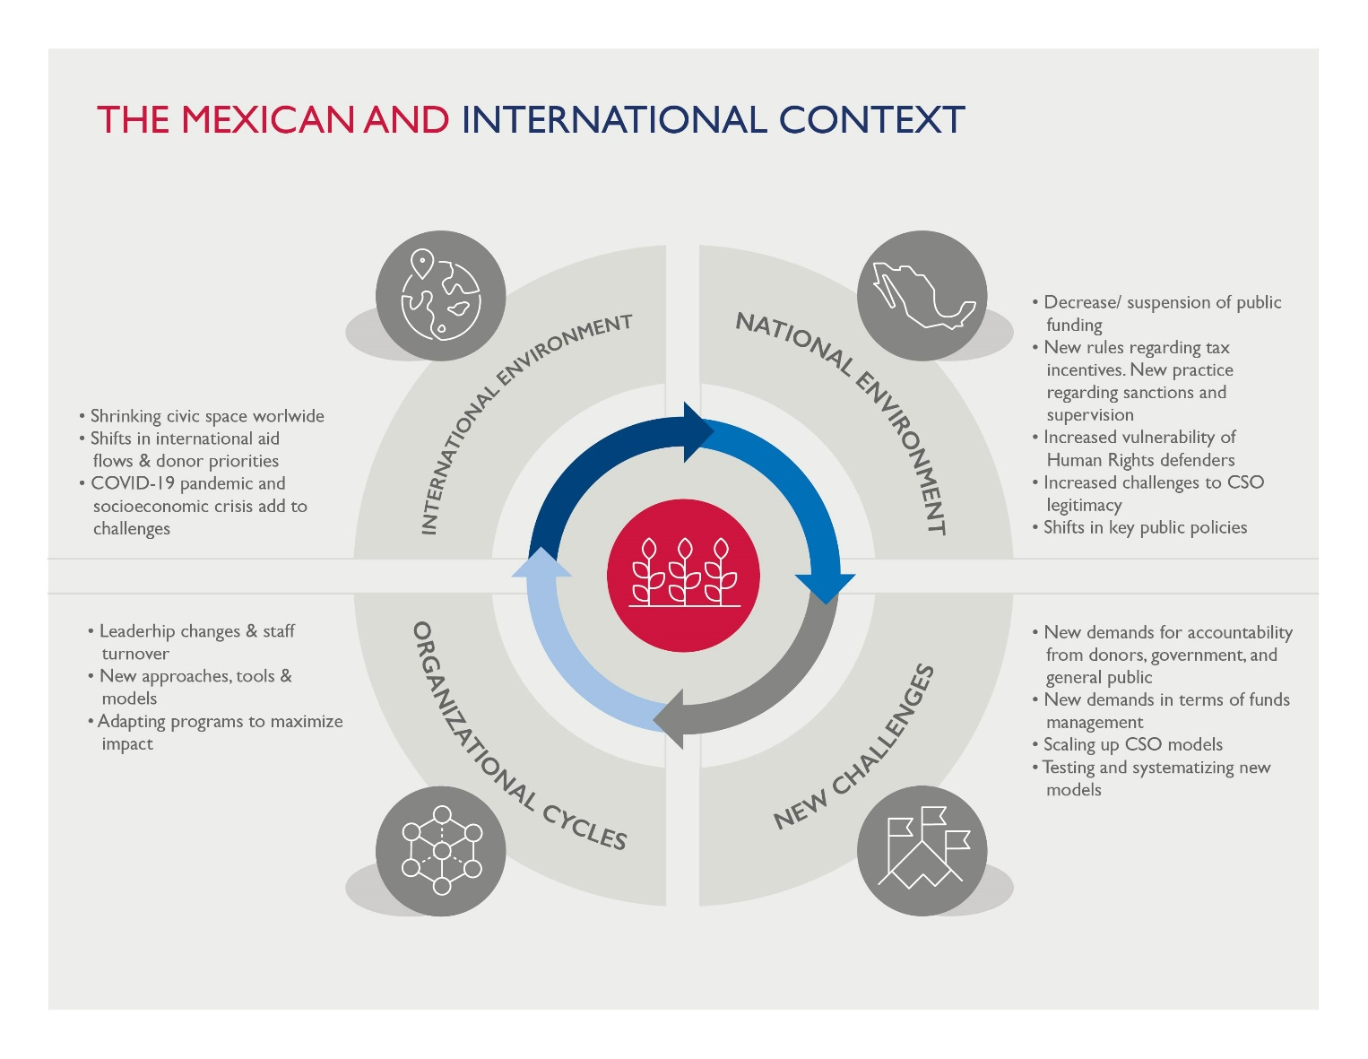

III. The Adaptive Management of Capacity Development
For a capacity development intervention and program to be successful, it must be rooted in adaptation and flexibility. During its four-year period of performance, CSA gradually incorporated greater emphasis on adaptation and flexibility when framing the narrative around capacity development, when responding to the realities of partner CSOs’ resistance and absorptive capacities, and when implementing performance solutions. As part of CSA’s approach to adaptive management, the Activity identified the importance of 1) effectively communicating about capacity development and its importance throughout the strengthening process, 2) defining and managing the absorptive capacities of partner organizations, and 3) ensuring that customized approaches are applied from the point of first formalizing the collaboration, through the implementation of performance solutions, through the conclusion of the capacity development process.

Communicating Capacity Development and Its Importance
Early on, the CSA team faced the communications challenge of explaining to its partner organizations what capacity development is and how it could benefit them. During this early phase, CSA’s partner CSOs made it clear that their priority was to attend to their particular social cause, whether that be providing support to the families of those forcibly disappeared, victims of gender-based violence, incarcerated populations who lack access to justice, or youth in vulnerable communities that experience high levels of violence and poverty. Taking on a capacity development activity that was foreign to them would divert CSO staff from their day-to-day activities and could also divert resources away from their important work. The CSOs did not see a direct link between capacity development and improved impact; the urgency – and in some cases, danger – of their mission took precedence over organizational strengthening, collaboration, and systems thinking.
Over the course of CSA implementation, the team refined the way it communicated about capacity development. This was a careful balancing act, because sustaining CSA’s results depended on partner organizations understanding and applying the integrated capacity development approaches. Rather than being overly pedantic about the methodologies and frameworks that underpin CSA’s work, the team gradually began to reframe the narrative they were transmitting to partners, focusing less on the theoretical and more on the practical and technical aspects of capacity development and its purpose. For instance, rather than emphasizing the differences between different generations of capacity development (Human and Institutional Capacity Development vs. Capacity 2.0), it was clear that partner CSOs needed to hear how an approach that integrated both would benefit their organizations and improve the lives of the people they serve. This shift in narrative was absolutely necessary to increase the level of trust among CSA and its partners; convince them that participating in capacity development was a worthwhile venture that directly advanced their social objectives; and accelerate the delivery and replication of CSA’s support.

Openness, Commitment and Investment
Regardless of how well a capacity development program is designed and executed, there will always be organizations that are not in the position to take on the commitment or dedicate the time that capacity development requires. Simply put, the organization may lack openness, organizational commitment or enough investment of staff time and effort to embrace the challenging task that is their own institutional strengthening. This may be a matter of timing in which an organization may be dedicated to other projects or may lack the resources or staff to collaborate actively and sufficiently in such an Activity. In some cases, the lack of openness, commitment and investment may be a result of leadership styles that foreclose the option from the outset. In other cases, the resistance to embrace capacity development may be present across the organization. In these circumstances, it would be difficult (and inappropriate) to force the organization to move forward with a process as demanding as capacity development, and the implementing program may need to reevaluate the scope of the intervention or terminate the partnership.
Emerging Practices for Communication
- When introducing organizations to capacity development, connect the process and its outcomes with what they view to be impactful, particularly related to the implementation of their programmatic work and their attention to target populations.
- Be patient with organizations and with your team as you find a balance between communicating what capacity development is and how it can be beneficial.
- Maintaining commitment takes time and effort. When beginning the capacity development process, be patient in collaborating with partners who express initial resistance to see if they become more receptive as they learn more about what capacity development is and what the process requires of them. Also, once organizations demonstrate commitment, periodically reevaluate how to maintain and perhaps improve their commitment over time.
- If it becomes clear that the organization is not prepared to fully invest in the capacity development process, reevaluate the scope of the intervention by identifying specific forms of strengthening that are feasible and relevant given the level of commitment. If, after repeated attempts to engage the organization, that level is untenable, consider possible termination of the partnership.

Structuring a Capacity Development Team
A key factor that contributed to CSA’s ability to adaptively manage various complex capacity development processes at once while maintaining effective communication with partner organizations related to the structure and profile of the implementing team. Given the wide range of technical support and follow-up that each capacity development intervention required from different teams (Institutional Strengthening, Monitoring and Evaluation, Grants, Communications, Legal Strengthening, Administration and Leadership), it was important for CSA to structure its staff in a way that contributed to the proper flow of information and the efficiency of complex processes. For CSA staff, understanding how each team contributed to organizational development through distinct mechanisms had strategic significance. Ultimately, the ability to accompany more than forty civil society organizations depended on a properly structured implementing team.
CSA’s internal organizational structure evolved over time. One of the most significant structural decisions was to appoint members of the Institutional Strengthening team as Points of Support to specific partner organizations. As Point of Support, the assigned CSA staff member was responsible for the supervision and coordination of all capacity development processes, not only those processes that pertained to institutional strengthening as such, but also processes that were executed by other teams, including Monitoring and Evaluation, Grants and Communications. The Point of Support was included in all correspondence to ensure that information was directed towards the relevant individuals, and that processes were carried out on-time and in an appropriate manner. This structure dramatically improved communication between organizations and CSA, as well as among CSA staff. Ultimately, this structure also improved communication with USAID, as the Point of Support could be consulted on any issue pertaining to an organization and know how to access the information.
Working in collaboration with Points of Support, various teams provided direct technical support and follow-up to capacity development processes. The Monitoring, Evaluation and Learning (MEL) team served a vital role in ensuring that the Activity was constantly advancing towards established goals outlined in the Results Framework and using Activity-wide indicators in the Activity Monitoring, Evaluation, and Learning Plan (AMELP). They defined the path that the team would follow and set the parameters to customize implementation. As part of this support, the MEL team developed a series of trackers to register how organizations were advancing in their capacity development. The trackers provided information on when adjustments were required and allowed for easy reporting. Moreover, the MEL team assembled a group of consultant-experts who were assigned to the partner organizations to provide individualized technical support during the development of Logical Frameworks, indicators, databases and quarterly reports, and in follow-up to the organizations’ implementation of their thematic projects. These consultants intervened during the implementation of other performance solutions in order to guarantee coherence with MEL systems and instruments.
Figure 8 demonstrates how the Points of Support who were based in the Institutional Strengthening team worked with CSA colleagues across the other teams to support their assigned CSOs.
Figure 8. Coordination by Points of Support 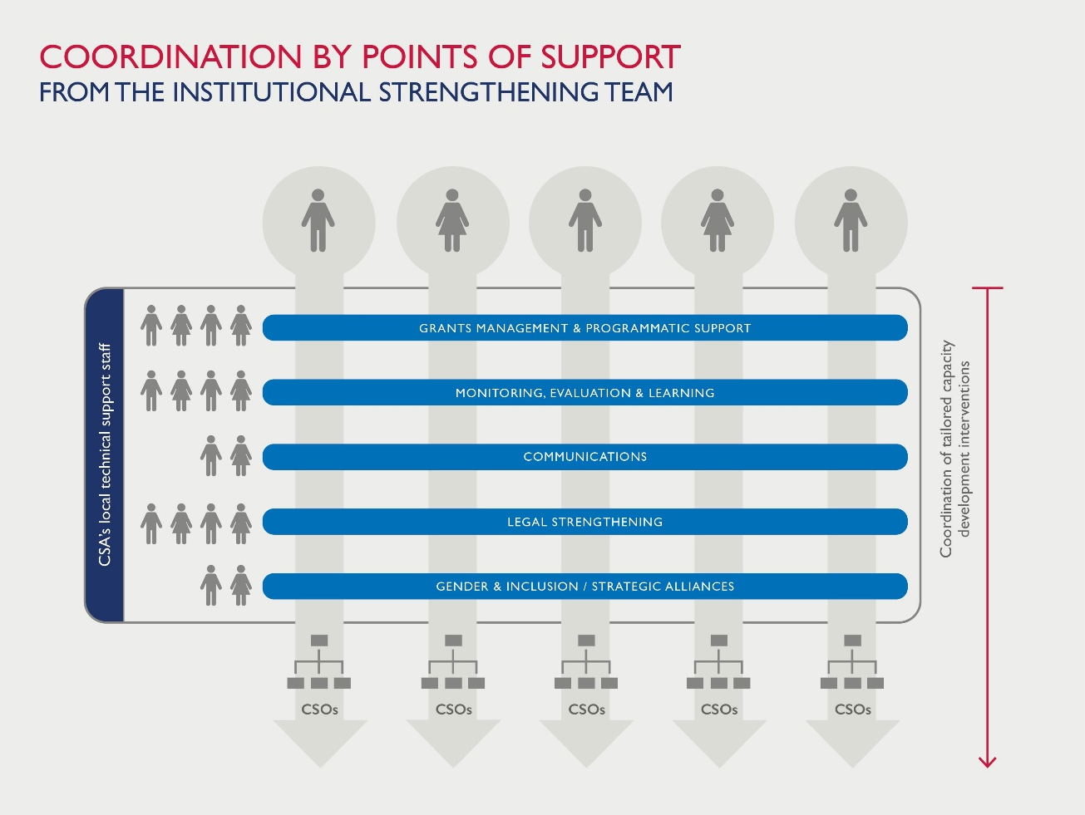
The Grants team also played a critical role in supporting capacity development implementation by overseeing the connection between the thematic projects that CSA grantees carried out, as well as monitoring the CSOs’ management of their grant budget and balance. When seeking to define customized approaches, the Points of Support turned to the Grants team to inquire into the status of the grantees’ CSA project implementation to know when strengthening activities needed to be put on hold given the workload of grantee organizations’ staff, or when they could be accelerated during down time, effectively “checking the pulse” of the organizations’ activities to make adjustments accordingly. The Grants team and Points of Support also worked together to support organizations that needed to improve the rate of expenditure of their grant by identifying activities and products that could be prioritized to program and spend according to budget, and ensuring organizations’ had adequate capacity to do so. Ultimately, the Grants team was key in bridging programmatic implementation with capacity development to help ensure that both components advanced in a balanced way.
Over the life of the Activity, CSA made iterative adjustments to organizing the work of different teams, which required clear communication with partner organizations to help them understand how to interact with CSA staff. After CSA implemented the structure depicted in Figure 8, partner organizations came to realize that they simply needed to reach out to their Point of Support to request guidance, after which needed internal coordination within CSA automatically followed. As CSA institutionalized and socialized the Point of Support role, organizations felt more comfortable communicating challenges and managing workload and deadline requirements because the Activity’s component teams were no longer siloed and were thus more responsive and adaptive.
It was also imperative to establish efficient communication and coordination with technical experts and administrative support in SI’s home office in Arlington, Virginia. During implementation, CSA was in constant dialogue with SI Headquarters staff and received their support in the drafting and approval of deliverables, annual work plans, strategic documents, budgets, and contingency plans during the COVID-19 pandemic, among many other products. From the outset, it was important to define how the home office and local office in Mexico were to collaborate in order to deploy and coordinate their respective assets to accomplish CSA’s objectives. This relationship also evolved over time in response to the changing demands of the Activity.

Transferring Capacity Development Knowledge and Skills to Multidisciplinary Experts
In order to carry out the range of capacity development interventions that CSA set out to implement with more than forty organizations in a tailored and integrated fashion, having a roster of adept and agile consultant-experts was essential. In total, the Activity convened and coordinated a team of more than twenty consultants and three subcontractor organizations that were responsible for implementing performance solutions. CSA held recurrent training sessions and workshops both to inform consultants of the Activity’s capacity development approach and the technical requirements to operationalize the approach, and to receive consultant feedback on best practices and lessons learned in order to make improvements as needed. Successful implementation depended on the careful coordination of this large team of consultants and subcontractors, each with specific areas of expertise who attended to the performance needs that were identified by CSA’s partner organizations during the base-line assessment.
As consultants and subcontractors were on-boarded, the Institutional Strengthening team provided recurring in-depth workshops to transfer and reinforce CSA’s capacity development approach, including methodologies, instruments and reporting requirements, both at the beginning of their contract and during their implementation of performance solutions. For instance, the Institutional Strengthening team facilitated a series of participatory workshops with the consultant-experts based on USAID’s CLA approach in which they reflected on their work using CSA’s framework, guidelines, processes, roles and responsibilities, and provided feedback. In a subsequent workshop, consultants learned about change management and facilitation, as well as more general facilitation skills. Afterwards, consultants identified and documented best practices and lessons learned during the implementation of performance solutions, which served as a key source of information for this document. These iterative exchanges provided new consultants the opportunity to assimilate themselves into CSA’s work dynamic and provided the opportunity for other consultants who had collaborated with the Activity to transfer knowledge and skills.
CSA staff continuously reflected and acted upon ways to improve coordination and communication among consultants, the Activity’s staff, and the organizations to which they offered support. This process was driven in part by the continuous growth of the pool of consultants whom CSA engaged. Towards the end of implementation, it became clear that consultants coordinated by CSA’s Monitoring and Evaluation and Grants teams needed to communicate more effectively with consultants in charge of implementing tailored solution packages that the partner CSOs had prioritized based on their organizational performance assessment findings. This improved cross-team communication was essential to guarantee that interventions were connected and coherent in terms of methodology and timing, and that the number, magnitude, sequencing and connections between the interventions did not exceed partner organization absorptive capacity.
One of the most enduring obstacles that CSA experienced in assembling a team to implement performance solutions was in working with subcontractors that had been selected based on their influence and track record in strengthening civil society. Over the course of implementation, CSA collaborated with three subcontractors to implement Strategic Planning, Human Resources, Gender and Inclusion, Financial Strategy and Resource Mobilization solution packages with a sizable number of partner organizations. Although CSA provided a training session to each subcontractor to transfer the Activity’s systemic approach, each subcontractor came to CSA with a pre-established methodology and way of working that they had fine-tuned during their own implementation with CSOs in different parts of Mexico. At times, this caused a discrepancy in how methodologies and tools were applied with CSA’s partner organizations. To correct course, the Institutional Strengthening team held weekly or biweekly meetings to follow-up on implementation, provide feedback, and dictate specific next steps.
Emerging Practices for Team Composition
      - Assemble a robust, multi-faceted team with a wide range of technical capacities and work experience to coordinate diverse capacity development interventions in a tailored fashion. While building this team, bear in mind the operating budget as well as the number and absorptive capacity of partner organizations related to the performance solutions and other capacity development interventions they are to receive.
      - Develop well-structured work flows to organize roles, responsibilities, and tasks among staff, consultants, subcontractors, the client, and home office (if applicable) in a way that facilitates clear communication and processes to achieve results and ensure organizations know where to turn for guidance.
      - Consider assigning a single point person to each organization to coordinate the variety of complex capacity development interventions with other teams and share information accordingly.
      - Avoid compartmentalizing the various capacity building teams; institutionalize mechanisms and interactions in which teams can efficiently exchange information and coordinate work processes.
      - Design and execute a series of iterative, participatory training workshops with staff, consultants and subcontractors who are responsible for implementing performance solutions in order to transfer the capacity development approach, provide feedback, reflect on lessons learned and best practices, and exchange information.

Managing Absorptive Capacities
Well into CSA implementation, after the early conversations to introduce the partners to capacity development, the team faced a new set of challenges in collaborating with CSOs that possessed different levels of capacity to receive and use outside support and then participate actively in their own development. This characteristic, known as absorptive capacity, is a multidimensional quality of organizations that is shaped by a variety of factors. As described below, these factors include:
- Organizational Structure
- Organizational History and Size
- Legal Status and Grants Administration
- Decision-Making and Leadership Styles
- Openness, Commitment and Investment

Organizational Structure and Complexity
CSOs have highly diverse organizational structures relative to other sectors, which is related to the heterogeneous nature of the “third sector” itself. These differences can be consequential: An organization’s structure determines how its work is carried out and is intimately connected with the other factors examined here that determine absorptive capacity. For instance, structure is in part determined by the size of the organization and the composition of its various units, which may be defined by program or geographic implementation area, or at times by administrative, operational and strategic teams. Organizational structure can also differ over time within the same organization, where an organization may start out as incipient with an informal structure lacking clearly defined roles, move on to solidify its operations and adopt an established structure, and then return to an informal state, with each shift marked by periods of transition.
Academic institutions and actors from other sectors who contribute to civil society may be good partners in capacity development processes directed towards civil society. For instance, CSA collaborated with academic institutions whose role is to strengthen CSOs through research, training, certifications, and other forms of knowledge exchange and professional development. Accordingly, it was crucial for CSA to rethink its response given the different organizational structure of universities. The challenge was to accompany a small, isolated division within an academic institution in coordinating the division’s internal capacity development processes in a way that produced a positive impact on the capacities and performance of the entire university during a period of significant staff rotation. This required CSA to pause, reflect, and redirect how it communicated and monitored the responsibilities of the university stakeholder committee to encourage them to adopt a more integral approach that transcended the siloes of the university system, to improve the entire institution’s performance and the educational services it provides to CSOs.
Emerging Practices Relating to Different Organizational Structures
- Target specific staff and organizational units to participate in capacity development interventions and to socialize improvements with their colleagues. Some interventions should be directed to one or two key personnel through mentoring, while others should be directed towards a broader group, such as more participatory workshops with an entire programmatic area or all operational staff.
- Assign, document, and follow-up on the responsibilities of organizational staff who are in charge of internal coordination of the strengthening process as members of a capacity development stakeholder group. Ensure they understand the approach and what is involved. Check-in regularly with the stakeholder committee to orient and motivate decision-making and attend to any needs that emerge as a result of staff rotation.
- Provide each CSO detailed reference materials on the scope of capacity building, ensuring that all relevant members of the organization (not just the leadership) have access to information and that all new staff are properly informed as they are incorporated into the process.
- Prioritize the systematization and socialization of lessons learned as well as new processes, tools and policies following key capacity development interventions to inform all relevant members of the organization, support broader uptake, and avoid limiting access to new skills and knowledge to one individual or small group.
- Explore new methodologies, tools, approaches and forms of support, particularly when working with organizations that are different from typical partners. Different kinds of organizations may absorb the same methodologies differently and may require new methodologies.

Organizational History and Size
Early-on, the CSA team observed differences in the absorptive capacities of organizations of different size and with different track records, although these differences did not affect absorptive capacity as the team expected. For example, CSA found that organizations with a large operating budget, teams of twenty or more staff, and an established track record in their region may be overrun with projects receiving other donor support. These organizations have often generated the social capital that reinforces their role in the local system, causing them to lose sight of areas of opportunity to refine their internal organizational systems and processes as part of a process of continuous improvement. In addition, larger organizations may assert that they already have sufficient capacity; consequently, they may lack the openness to critique themselves and address areas of strategic opportunity. For these reasons, capacity development may not be their first priority.
By contrast, CSA has found that smaller, more incipient organizations may be more willing and interested to take on capacity development, because they already assume – or know – there are several areas of opportunity to improve their performance. In CSA’s experience, it was possible to see remarkable progress in smaller organizations beginning with the implementation of the first performance solutions, particularly with core performance solutions in the areas of Strategic Planning, Resource Mobilization and Legal Strengthening. Furthermore, smaller organizations tend to have fewer programs and projects, and were more able to direct their full attention to the strengthening process. However, it is important not to generalize about the impact of organizational size on an organization’s willingness to embrace capacity development; there are always larger organizations that demonstrate an openness to own the process as much as smaller organizations, just as smaller organizations that are experiencing transition or precarity may be ill-inclined to take on capacity development.
Emerging Practices Sensitive to Organizational History and Size
      - Consider the organizations’ history and size from the beginning of the capacity development process to define the specific juncture and context in which strengthening interventions take place as well as how well this support attends to organizational priorities and needs.
      - Reevaluate the organizational context throughout the capacity development process to be aware of its evolution and adjust accordingly. Organizations are in constant transformation, both internally and in terms of their role in their operating environment.

Legal Status and Grants Administration
An organization’s absorptive capacity is also defined by its legal constitution and capacity to manage and administer donor funds, such as USAID grants. These interrelated characteristics of an organization can determine the extent to which a CSO is able to carry out certain activities. This was one of CSA’s most foundational lessons learned, drawn from experience with various organizations. For instance, some CSOs that received USAID-financed grants from CSA required individualized attention to help them comply with special award provisions based on the results of their Non-US Organization Pre-Award Survey (NUPAS) assessment. In one organization’s case, CSA ultimately directed all its capacity development efforts towards these required areas for improved performance, due in part to the fact that the organization was not prepared to take on other capacity development interventions. In another case, CSA learned to adapt to an organization that was not prepared to replicate the Activity’s grants and institutional strengthening management processes with subgrantee civil society organizations, given its legal and administrative capacities. (Refer to section below on Transfer and Replication of CSA's Capacity Development for more information). Upon determining it was not possible to move forward with the replication of CSA’s capacity development approach, the organization received a CSA grant modification to remove the replication and institutional strengthening component and to focus entirely on implementing its USAID-funded CSA grant project.
Emerging Practices Related to Legal Status and Grants Management
- Identify which organizations have particular needs in terms of compliance with USAID grants administration standards and accompany them through the process of institutionalizing NUPAS standards as a first priority before moving on to subsequent capacity development interventions.
- When strengthening Intermediate Support Organizations that are preparing to administer USAID-funded grants to other organizations for the first time, review the ISOs’ legal status and administrative capacities to determine whether they have the systems and legal standing to do so. Should the conditions exist for them to perform this role, focus on developing these required grants administration capacities to enable them to achieve compliant grants management.

Decision-Making and Leadership Styles
Decision-making structures and processes differ radically among civil society organizations. Although they may be connected to the organizational structure, decision-making structures, or what can be described as the “chain of command,” may vary from (and be more flexible than) the organizational structure itself. Some CSOs are vertical in their decision-making processes: Strategic and operational decisions derive from a Board of Directors, are channeled through leadership, and are transmitted to staff via departmental leaders, as is normally seen in the private sector, for instance. However, other organizations are horizontal and participatory in their strategic and operational decision-making processes and exhibit different consensus-making models, at times lacking a fixed organizational structure entirely. In between these two extremes exist the majority of CSOs with some mix of horizontal and vertical decision-making processes. A key factor determining decision-making structures is the leadership styles within organizations. These leadership styles and behaviors determine a variety of dynamics during any capacity development activity. In CSA’s experience, the role of leadership styles is most present during the process of strategic planning in which the organization undergoes significant change.
On many occasions, leadership styles dramatically affected the viability of CSA’s capacity development interventions. In the case of several CSA partner organizations, the leadership firmly maintained that their organizations already possessed strong internal capacities and performance in areas where the organizational performance assessment had, in fact, identified opportunities for strengthening. This was very often the case in the performance area of mainstreaming gender and inclusion. As a performance area intimately tied to organizational culture, gender and inclusion generated sharp resistance from many Directors, men and women alike, especially among organizations located in the north of Mexico where machista culture is most present. For these organizations, the idea that they had not mainstreamed a gender-based and inclusive approach contradicted who they considered themselves to be as individuals and organizations working to advance social causes – when in reality, the area of opportunity was to ensure this approach was properly institutionalized (i.e., documented and implemented in practice), which has nothing to do with one’s moral position. For these reasons, it was important to generate change agents to mobilize shifts in organizational culture who were outside of traditional leadership circles.
It is also important to note the role of Boards of Directors and organizational Directors in creating the required conditions for capacity development, among them ownership and internal coordination. In cases where organizations have a large Board of Directors, the decision-making process may impede or delay interventions. This underscores the importance of guaranteeing buy-in from the Board from day one of implementation and involving them in the stakeholder groups that oversee the strengthening process. Over the course of partnering with a diverse pool of organizations, CSA learned the importance of promoting collaborative leadership styles among Boards and Directors in order to foster workplace dynamics that leveraged the expertise and abilities of all members of the team. Figure 4 provides the characteristics of collaborative leadership.

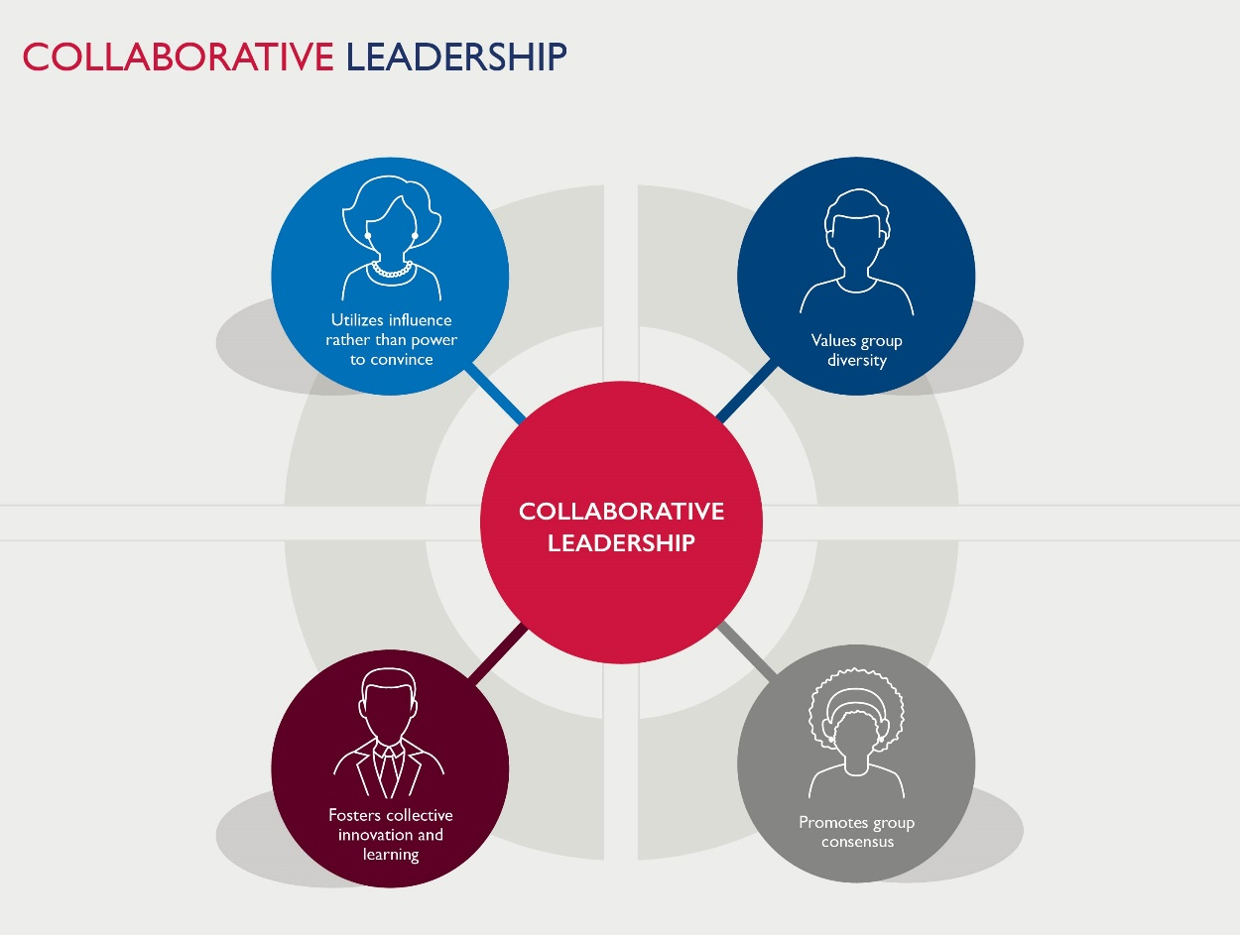
Figure 4. Characteristics of Collaborative Leadership
Finally, it is important for Directors to assume responsibility for ensuring proper coordination during implementation and follow-up to capacity development interventions to prevent the compartmentalization of efforts and inadequate participation. For this to be possible, it is vital that Directors understand the scope of the capacity development by clarifying early-on that they will undergo an accompanied process to strengthen organizational processes, systems and performance with the support of technical experts. Further, Directors must understand that capacity development entails co-construction, and that the role of specialists who will accompany them is not to produce new policies, protocols or systems themselves as though they were in-house consultants.
Emerging Practices Related to Decision-making and Leadership Styles
- Identify leadership styles that are present within organizations early-on in the capacity development process and determine best practices when collaborating with different styles.
- Practice adaptive management in the design and execution of capacity development interventions to respond to different and emerging decision-making styles, structures, and processes in a flexible manner.
- During the Strategic Planning process, prioritize the coaching of organizational leaders to help strengthen their ability to facilitate change and implementation of new strategic objectives.
- Develop a sequence of activities in the organizational strengthening process that fosters collaborative leadership styles to facilitate change as new processes and systems are being created and institutionalized for the first time.

Customized Approaches
The Civil Society Activity’s capacity development model supported customized approaches that responded to partner organizations’ needs based on diverse characteristics, including leadership styles, organizational structure, work styles, and size, among other factors. In doing so, CSA sought to ensure that implementation of performance solutions was not only impactful, but that their impact would be sustainable over time. Prioritizing the customization of performance solutions added a significant degree of complexity to institutional strengthening, requiring flexibility and responsiveness to changing circumstances. In the process, CSA learned that customization itself requires adaptive management.
Truly customized approaches to capacity development are only possible if they are supported by adequate methodological design. More traditional capacity development approaches that focus on the transfer of skills and knowledge through one-off training sessions have proven to have short-term impact because staff rotation may erode new capacities. Also, individual trainings may be disconnected from other interventions, resulting in fragmented or incomplete organizational processes and systems. Marking a purposeful departure from training and the transfer of skills and knowledge as a form of strengthening, CSA developed a multifaceted and systemic methodology of capacity development, bringing together tailored interventions to strengthen internal capacities, improve organizations’ outward-facing performance, improve resilience and create enabling conditions for the civil society sector as a whole.
Given the multiple dimensions of the Activity’s methodological design, partner organizations participated in a wide range of individualized capacity development interventions to strengthen processes, systems, and performance in different ways and to different effect. For instance, on one hand, an organization received different tailored performance solution packages to improve internal processes and systems, such as in Strategic Planning. Prior to Strategic Planning, the same organization participated in a stakeholder mapping exercise to define how to maximize its impact based on its own role and resources, and how to leverage those of other actors by forging strategic alliances. In addition, as complementary exercises, this same organization participated in a Learning Community with other CSOs to exchange best practices, lessons learned, models for social interventions, and information on possible allies to further refine and set into motion its strategic plan and accomplish its intended results.
By incorporating USAID’s Capacity 2.0 model partway into implementation, CSA fully embraced the “Best Fit” approach to capacity development, whereby each intervention is designed and executed according to the context in which it occurs. Upon adopting this approach, CSA viewed improved performance not only vis-à-vis increased internal capacity, but also in terms of the organization’s connection to a wide range of individual and organizational actors that influence its social agenda. In practice, holding true to the “Best Fit” approach required the continuous analysis and adaptation of CSA’s interventions to ensure their relevance and impact given the partners’ internal characteristics as well as the range of actors that participate in their local system and the conditions that shape their interactions.

Flexibility of Capacity Development Assessment Tools
As CSA’s approach shifted to embrace adaptability and a systemic focus, the Activity’s resources and tools needed to shift, as well. After the contract modification in 2018, CSA embarked on the integration of various assessment instruments into a single flexible, semi-automated tool. CSA’s Integrated Assessment Tool enables assessing various dimensions of organizational performance in a tailored fashion: it allows for both modular and full application, depending on the organization’s needs and the amount of time they would dedicate to the capacity development process. Thus, CSA’s Integrated Assessment Tool itself permits customized approaches to organizational performance assessment. Facilitators can use this one tool to apply diverse assessment instruments, record qualitative observations, draw results, generate graphs to demonstrate findings and draft preliminary recommendations.

Developing the Integrated Assessment Tool required a dynamic and iterative process of collaborative design, piloting, modification and evaluation that involved a multidisciplinary team of consultants and experts from CSA’s office in Mexico City, Social Impact’s Home Office and USAID/Mexico over the course of several months. CSA also actively sought the feedback of partner organizations that participated in early pilots of the Tool to define what worked best for them, a process rooted in Collaborating Learning, and Adapting. During this process, one of the instruments, the Organizational Capacity Assessment (OCA), went from having more than 800 criteria to having 300 criteria across eight performance areas. This made the tool more agile and user-friendly to support self-application, so that organizations can identify priority areas of opportunity in which to implement performance solutions over time and on a recurring basis.

CSA’s Integrated Assessment Tool is a product of the innovation that Social Impact, its partner organizations, and USAID/Mexico have dedicated to enhancing current development methodology and practice. USAID Washington also provided feedback during the Tool’s design and its pilot process. Moreover, because the Integrated Assessment Tool provides a set of instructions for facilitators, specific assessment objectives, and a built-in glossary with click-and-go elements, its design promotes a user-friendly interface that aligns with Social Impact’s focus on utilization. By advancing the integrated design and feasible application of organizational performance assessment, CSA has contributed to the impact and sustainability of capacity development in Mexico’s civil society sector while advancing innovation within the capacity development community more broadly.

Figure 5 presents the dashboard of the Integrated Assessment Tool. Figure 6 provides an example of the semi-automated results that are produced through the Tool. The graph on the left demonstrates the output-level results gathered through the Organizational Capacity Assessment (OCA), and the graph on the right illustrates outcome-level results of the Organizational Performance Index (OPI).

Figure 5. CSA’s Integrated Assessment Tool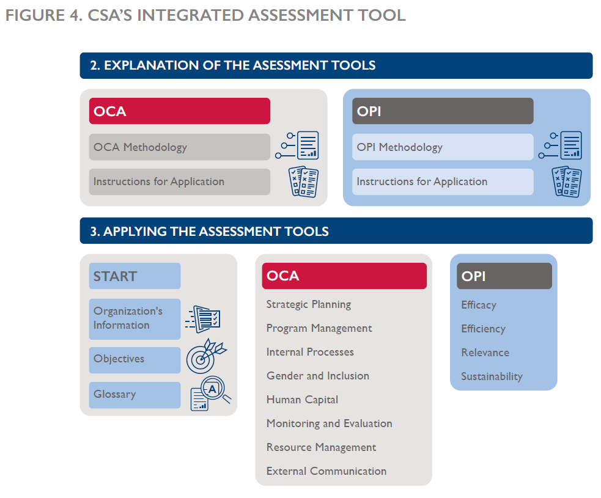
Figure 6. Example of Semi-Automated Results
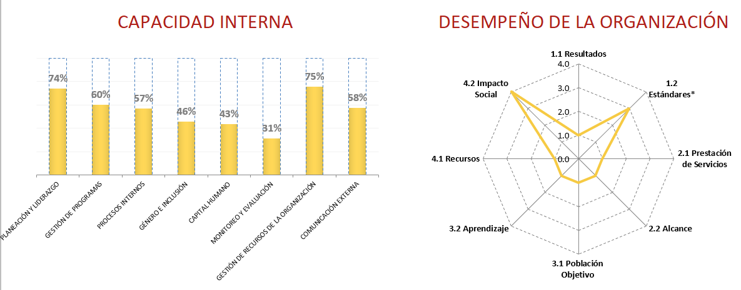
Emerging Practices for Customization
      - Consider both internal and external dynamics when designing and implementing customized approaches to capacity development, considering not only the needs and characteristics specific to the organization itself, but also the conditions that produce an enabling environment and improved impact given the organization’s external context and the various actors with which it interacts.

      - Think beyond one-off trainings and mentorship to design a series of iterative, tailored and fully integrated capacity development interventions that privilege the institutionalization of new systems and processes based on what is sustainable for each organization.

      - Embrace a holistic “best fit” approach to capacity development, seeking out the most appropriate approach during each intervention and avoiding the replication of linear “best practices” that do not produce the same results in different contexts.

      - Adopt an iterative and collaborative approach when designing, piloting, modifying and evaluating the assessment tools that are used to identify areas of opportunity for institutional strengthening. Prioritize their flexible use so that organizations can determine how best to utilize assessment tools based on their needs and constraints.

      - Be prepared to confront unintended consequences that may arise over the course of capacity development interventions by embedding flexibility and embracing change facilitation in program design as USAID’s Local Systems framework suggests.

Adaptive Management of the Replication of Capacity Development by Strengthening Organizations
Four of CSA’s partner organizations were Intermediary Support Organizations (ISOs) responsible for receiving and replicating the Activity’s capacity development approach with fourteen subgrantee organizations. During the first two years of implementation, CSA transferred to these strengthening organizations the tools, methodologies and performance solutions that comprise its systemic approach. The transfer occurred through a series of CSA-facilitated individual and group workshops based in learning-by-doing and simulation methodologies. In early 2019, three of the ISOs began to replicate the capacity development process that they had experienced with their respective subgrantees, including the grant management and institutional strengthening components. At this time, one of the SOs decided to reorient its replication of CSA’s capacity development approach through academic training, an area where it had already established a reputation through its service delivery to the civil society sector, requiring a contract modification.

As the separate partner organizations carried out the replication process, their experiences served as fertile ground to observe and document fresh and innovative adaptations to CSA’s approach, adding another level to the Activity’s understanding of customization. Most notably, each of ISO that replicated CSA’s approach did so while also contributing a strengthening process in their thematic areas (for example, human rights, crime prevention and justice reform) in a systemic fashion. Further, two of the strengthening organizations prioritized replication of the strategic alliances component of CSA’s strengthening process through different mechanisms, such as a National Observatory on Arbitrary Detention and through stakeholder mapping and workshops. The third ISO replicated the strengthening process through a partner/subsidiary strengthening organization with which it had worked for several years.

The replication process taught CSA how its capacity development approach could also be tailored to the structure, strengths and constraints of ISOs that strengthen other civil society partners in Mexico. Although CSA required the ISOs to implement their own strengthening activities in a way that upheld the integrity of CSA’s integrated approach both methodologically and contractually, there was significant room for each ISO to choose how best to do it. As the Activity accompanied strengthening organizations along the way, CSA staff were struck by the ownership and creativity that each ISO demonstrated. At times, these strengthening organizations designed new ways of facilitating capacity development interventions to blend organizational development with strengthening the subgrantees’ thematic areas, such as human rights, crime prevention or justice reform. In other cases, the ISO altered the way that capacity development interventions were facilitated and communicated so that they were integrated in the day-to-day activities of the organization in a more experiential fashion. In one case, ISO scaled back implementation of capacity development with some partner CSOs to prioritize work others based on their particular needs. Along the way, the Activity learned how to clarify the minimum requirements of replication and grants management to the strengthening organization when there was room for flexibility, so that the ISOs were able to innovate new strategies on their own to respond to subgrantee needs and constraints.

Figure 7 illustrates the replication process. It is key to note that CSA adopted Collaborating, Learning, and Adapting (CLA) strategies throughout the process of transferring skills and knowledge to strengthening organizations, granting them space to learn by doing, which enabled them to understand and implement capacity development processes in a gradual fashion.

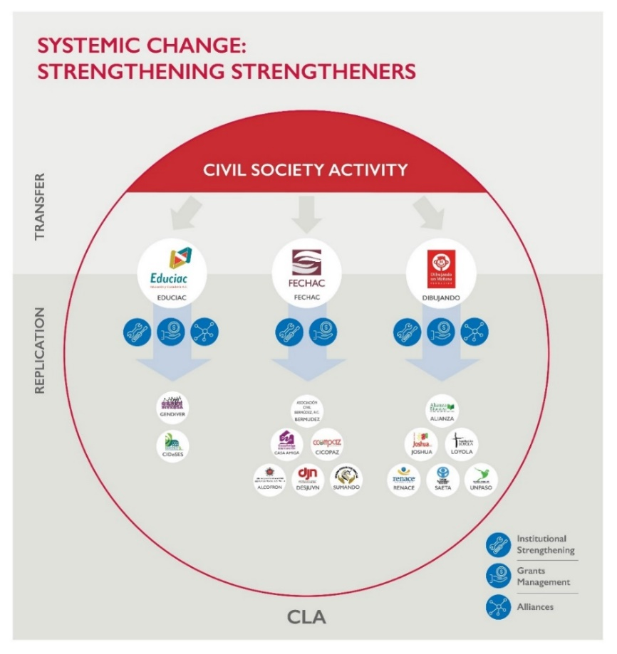
Figure 7. The Transfer and Replication of CSA’s Approach by Strengthening Organizations

Emerging Practices in Supporting ISO Replication of Capacity Development
- Identify and strengthen local actors (i.e., foundations, influencers, and donor institutions) that are committed to applying and adapting capacity development methodologies with their constituent organizations in the target country or region in a sustainable fashion.
- Determine the appropriate balance and proper link between strengthening organizational processes and systems and developing capacities to implement the organizations’ thematic work (for example, human rights, crime prevention or justice reform).
- Be clear in communicating the minimum requirements, core methodologies and best practices for the replication of capacity development from the outset, both during hands-on workshops and in a written guide. Provide continuous feedback and guidance, adjusting the approach as needed.
- Incorporate Collaboration, Learning and Adaptation (CLA) into every step when accompanying strengthening organizations that wish to carry out capacity development processes. Facilitate learning by doing activities that enable members of strengthening organizations to understand and execute new processes in a gradual fashion.
- Provide strengthening organizations the autonomy to make their own decisions on how to carry out capacity development when there is room for flexibility, given that they have already developed their own areas of expertise. Doing so increases ownership of the process and leads to innovation and surprising results.

IV. Conclusion
This document has provided a synthesis of lessons learned and emerging practices that the Civil Society Activity has identified to inform capacity development initiatives. When designing and implementing such programs for CSOs, the Activity found it vital to maintain an agile, customized and systemic approach rooted in adaptive management. Just as CSA followed an iterative process of implementation based on participatory design, stakeholder feedback and application of lessons learned, the CSA team hopes other practitioners can adopt and adapt these learnings and emerging practices to promote a culture of Collaborating, Learning, and Adapting in the capacity development community more broadly.
As part of its approach to Adaptive Management, the Activity found the following considerations most useful:
- Structuring a Capacity Development Team and Transferring Knowledge and Skills to Multidisciplinary Experts:
The capacity development implementer’s internal structure for providing technical support to civil society organizations should be aligned and coordinated to ensure that support is provided in an efficient and responsive manner. For CSA, the Point of Support model described in this document served well, in which one person from the Institutional Strengthening team coordinated all capacity development processes across the Activity’s different technical areas, including grants management and programmatic support; Monitoring, Evaluation and Learning (MEL); communications; legal support; strategic alliances and gender mainstreaming. Other practitioners may determine the most appropriate models given their teams and the needs, resources and the pool of partner organizations that they support. Regardless of the internal organizational structure and dynamic of the capacity development program, it is crucial to carry out a series of iterative and participatory training exercises in which the multidisciplinary team that coordinates and implements performance solutions is trained and can contribute feedback. These workshops are an essential part of the process of transferring and refining the capacity development methodologies, tools and performance solutions that the program has designed.

- Communicating Capacity Development and its Importance:
Adequately communicate to partner organizations (particularly members of the stakeholder group who coordinate strengthening processes) the responsibilities and commitment involved in capacity development. Not only should this communication occur at the beginning of the collaboration in a robust and documented fashion, but the capacity development team should continue to reinforce these commitments and responsibilities throughout the entire process and until the end of the collaboration, especially in cases of staff rotation.

In addition, during implementation, the capacity development team should adapt its approach according to the different levels of openness, commitment and investment that each organization demonstrates over time, including through contractual adjustments and fine-tuning in the organization’s institutional strengthening plan.
- Managing Absorptive Capacities:
Organizational structure, complexity, history and size should factor into how capacity development support is offered on a case-by-case basis, although these absorptive capacities may exist at different levels that may seem counterintuitive. For instance, larger organizations with a sizeable operating budget and a larger reach in terms of their potential impact are not necessarily more equipped in any given area of organizational performance; nor are they more prepared to take on robust strengthening. In fact, smaller and more incipient organizations may be more inclined to embrace capacity development to a fuller extent and may be more advanced in specific areas of organizational performance.

Also, the legal status of partner organizations may render them more vulnerable to certain limitations in terms of the types of capacity development support they are able to take on, particularly in terms of how they are able to manage and administer grants. Furthermore, decision-making structures and leadership styles have a significant effect on how strengthening activities are coordinated and appropriated, requiring capacity development practitioners to be attentive and responsive throughout implementation.

- Customized Approaches:
One of CSA’s most impactful lessons learned was how to understand, design and implement customized approaches with all partner organizations. Beginning with the call for proposals and selection process, the Activity found that it is imperative to hold purposeful conversations between the implementing Program or initiative and the donor about customization in the civil society capacity building process. Customized approaches should also be incorporated when designing and applying assessment tools so that findings and recommendations are relevant for civil society organizations based on their needs and constraints. CSA’s Integrated Assessment Tool provides one example of a customized tool that was constructed in a participatory fashion. The Tool permits modular or full use in order to identify priority performance solutions based on the organization’s situation, priorities, and performance needs.

Systemic Impact
Incorporating the approaches, emerging practices and lessons learned that are described in this document, CSA designed and implemented the following additional activities, which have contributed to the Activity’s systemic impact in the civil society sector in Mexico. Although the two activities below are not intrinsic to every capacity development program, they are provided as strengthening processes that may hold value for other practitioners:

A Sustainable Model for Learning Communities
CSA established three Learning Community groups as a key systems-focused intervention based in CLA. Each Learning Community group was composed of partner organizations and local leaders who collaborated and learned from each other through discussing topics of common interest; examining and clarifying operational and programmatic questions; and sharing lessons learned on capacity building and other topics. In addition to informing member organizations’ work and helping to improve their internal performance, Learning Communities strengthen the broader system by reinforcing existing relationships, establishing new linkages among member organizations, and pointing to new alliances and opportunities for collaboration in the Local System.

Study Tour Model
As an extension of the Learning Community concept that entailed South-South collaboration and learning, CSA designed and implemented a Study Tour in which leaders from Mexico’s civil society, government, and academic sectors traveled to Colombia to learn from key actors in the fight against the drug war in the country. Upon exchanging best practices in peace building and violence prevention during their time in Colombia, these leaders returned to Mexico to apply lessons learned. CSA Study Tour participants have designed a joint project in the Mexican state of Coahuila and formed their own Learning Community to continue to discuss ways to formalize mechanisms that more efficiently attend to victims of violence in the country. This joint project contributed to the prevention, sanctioning and reduction of gender-based violence through the prevention, procurement and administration of justice, providing focused and comprehensive attention to the women of the State of Coahuila de Zaragoza.

What Sustainability Means to the Civil Society Activity
Principles that drive “dynamic sustainability” were at the root of every CSA decision. In contrast to static measures for building sustainability that focus primarily on financing or skills transfer through training, dynamic sustainability required that the Activity be intentional in directing its attention to a broad range of organizational factors and contexts, such as leadership, management, and structure; participatory processes and accountability mechanisms; and organizational culture. CSA’s approach to dynamic sustainability also required that capacity development support and interventions be sufficiently flexible so that they may not only be replicated by the same actors in similar circumstances, but that they may also be replicated by a variety of different actors facing different circumstances. For this reason, CSA prioritized the analysis and transfer of its capacity development approach and developed a compendium of documented resources for strategic partners and others to continue to strengthen Mexico’s civil society sector. Ultimately, the sustainability inherent in this transfer and replication process is CSA’s contribution to the Journey to Self-Reliance that USAID mandates.
To help sustain CSA’s legacy in systemic capacity development in the Mexican civil society sector and in support of USAID’s Journey to Self-Reliance, the team has identified a set of priority design considerations and implementation practices. These may support the replication of CSA’s emerging practices in other capacity building contexts.
- Transfer of CSA’s Approach to Influencers
Throughout its partnership with strategic partners, and particularly during contract close-out in August 2020, CSA began to transfer its capacity development methodology, tools and performance solutions to sustain CSA’s systemic approach. Several of these partners had already accompanied CSA during the implementation of performance solutions, including influential Mexican strengthening organizations that build civil society capacities in the areas of strategic planning, resource mobilization and diversification, human resources with a gender-based perspective, and financial strategy, among others. By the conclusion of the USAID contract, CSA will have transferred its capacity development approach in a modular fashion to these influencers in addition to other strategic partners working to develop Mexico’s civil society sector. During this transfer, CSA has drawn upon the partners’ individual areas of expertise, as well as their role in strengthening the local systems where Mexican CSOs participate and increasingly interact by virtue of CSA’s implementation.
- CSA’s Legacy Compendium
In addition to this document, CSA has compiled a full CSA Legacy Compendium describing the Activity’s approach and practices, technical results, and lessons learned across the multiple contract components. This Compendium will be uploaded to USAID’s Development Experience Clearinghouse (DEC) platform and disseminated to strategic partners to enable international development and capacity development organizations, as well as their beneficiary partners, to find further information.
Figure 9 provides further detail:
Figure 9: The Civil Society Activity’s Legacy Compendium
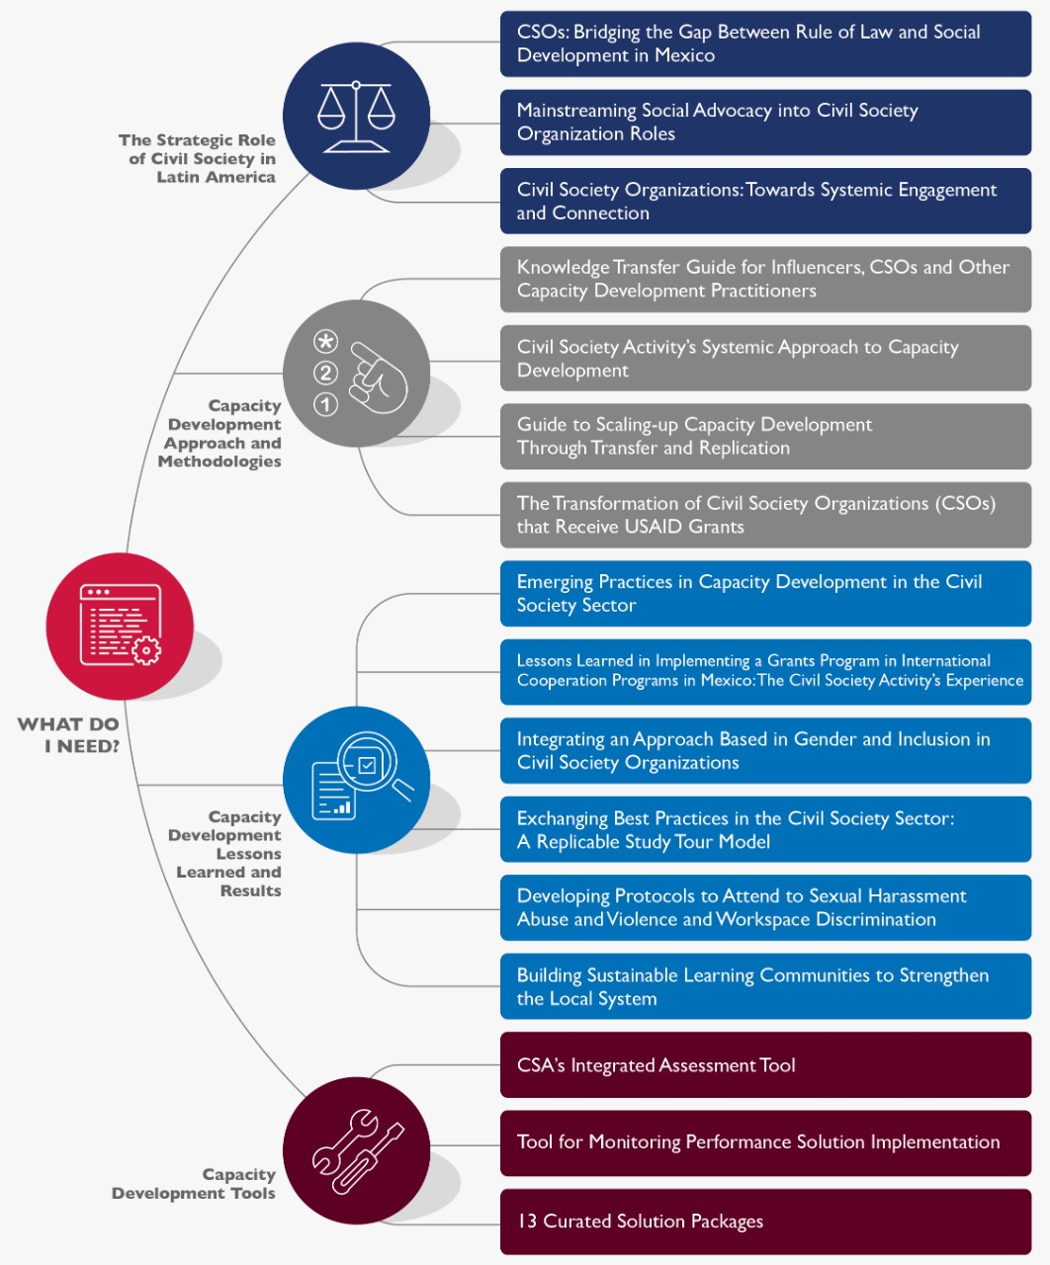

APPENDIX

Appendix 1: CSA’s Training with Consultant-Specialists based on Collaborating, Learning and Adapting (CLA)
CSA facilitated a participatory workshop with its pool of 20+ consultant-specialists to document and reflect on their experiences implementing CSA’s capacity development approach. The following excerpts provide a synthesis of the findings related to each question prompt.
Systematization of Best Practices Identified by CSA’s Consultant-Specialists
Based on your experience, why do you think it is important or relevant to strengthen the sector of organized civil society in Mexico?
Although there is goodwill and experience in the sector, there is little experience in key institutional performance areas to promote sustainability, particularly in areas such as strategic planning, M&E and administration. It is also important to produce a strong and empowered civil society sector that may serve as a counterweight to existing political structures with the objective of generating a truly democratic system.
Describe the two most important challenges you faced during implementation and how you resolved them.
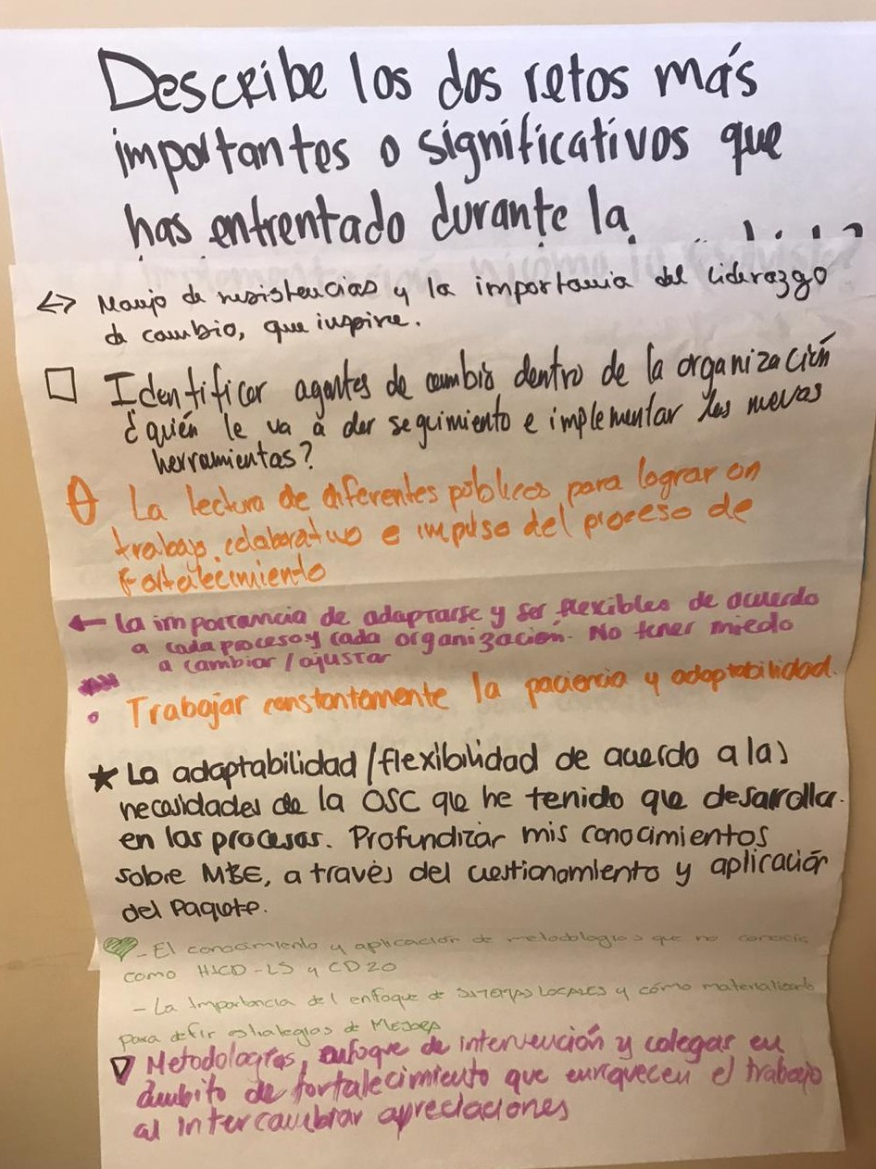
The consultant-experts’ most common responses related to communication and resistance to change, in addition to the reconciliation of agendas, the different scope of the solution packages (for example, planning and M&E), and access to information. Consultants highlighted the importance of identifying change agents within the partner organization and specific individuals who will be in charge of monitoring and implementing new tools as they are developed. Consultants also emphasized the need to be adaptable and flexible as each capacity development process may require and to encourage organizations to not be afraid to change or adjust. When leading a capacity development intervention, it is vital to listen to everyone and empower members of the organization to provide their opinion and respect spaces for dialogue and debate. From the outset of capacity development, it is key to establish a relationship with members of the organization that is based on trust so that, later, consultants are able to lead them by the hand through moments of transition and change.
Describe the two most significant lessons learned during implementation and how you integrated them into your work.
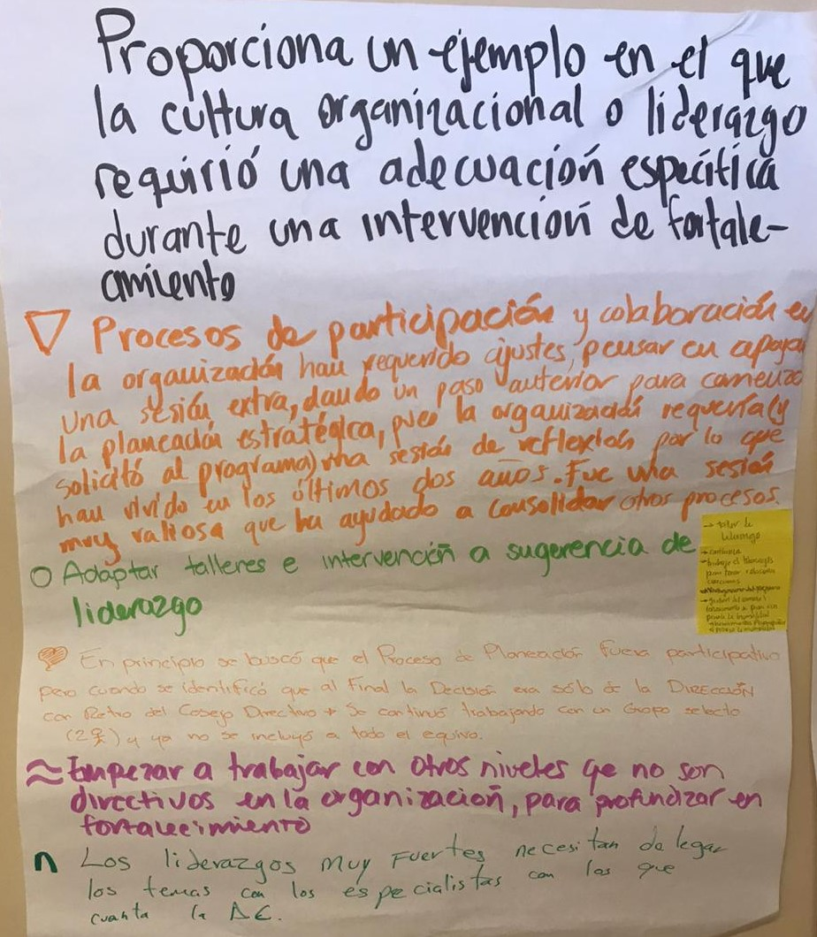
Consultants shared reflections centered on the need to be innovative and efficient in applying solution packages. At times, organizations may reject the technical support they receive in areas of opportunity for strengthening and performance improvement, including key areas of institutional strengthening that are contractually bound. Often, the capacity development process requires a level of commitment from CSO staff that exceeds the basic expectations codified in their grant agreement. Implementation must always be flexible and consultants must be empathetic when setting and maintaining deadlines, always promoting the ownership and autonomy of CSOs to establish their own priorities. Decision-making and implementation must always be participatory. Also, consultants stressed obstacles that they faced due to organizations being overburdened with work, which reduced their absorptive capacity and resulted in the lack of time CSO staff could dedicate to capacity development tasks.
Provide an example where the organizational leadership or culture required a specific adaptation during a capacity development intervention.
CSA’s consultants agreed that an approach rooted in participation and collaboration always requires adjustments along the way. They pointed to the need to determine the leadership styles and concentration of decision-making in partner organizations, as well as the importance of generating constructive relationships importance of generating constructive relationships with the leadership and other members of the CSO team to make them more comfortable in navigating current and next steps of capacity development. Moreover, the consultant-experts stressed the need to identify when the organization’s structure does not allow carrying out participatory processes. As one possible measure to address strong leadership styles, the consultants suggested creating a learning community for Directors and the adaptation of workshops and mentorship interventions based on different leadership styles.
Identify a moment in the capacity development process when the mainstreaming of a gender and inclusion approach can be incorporated and how this may be done.
Consultants shared the importance of identifying spaces for capacity development where women can be strengthened and empowered, particularly in areas of human resources, but also in developing M&E systems that adequately capture gender-sensitive and sex-disaggregated data. Performing M&E with a gender lens entails not only developing indicators and collecting data in the field with target populations, but also when establishing monitoring systems and gathering data on internal organizational operations. Also, consultants can support mainstreaming gender and inclusion by elevating this process during strategic planning and establishing expectations for the use of inclusive language in all materials and deliverables produced during capacity development. More generally, it is important to foster open and deliberate dialogue about what it means to incorporate a gender perspective with partner organizations.
Identify one specific area in which CSA strengthening can be improved or adjusted and why it is important to you.
Consultants identified the need for more clear and direct communication between those responsible for implementing different capacity development interventions with the same organization in order to improve coordination and collaboration around how to accompany the CSO in an integrated fashion. This type of synergy contributes to collective learning and reduces the triangulation of information. To improve communication in this way, consultants suggested weekly meetings among consultant-experts who accompany the same organization to discuss experiences, challenges, and lessons learned.

For more information on CSA’s approach, please consult Civil Society Activity’s Systemic Approach to Capacity Development, which is also part of CSA’s Legacy Compendium.
USAID. n.d. “The Journey to Self-Reliance.” Accessed July 27, 2020. https://www.usaid.gov/selfreliance
USAID (2011). Human and Institutional Capacity Development Handbook: A USAID model for sustainable performance improvement. Accessed July 27, 2020. https://usaidlearninglab.org/sites/default/files/resource/files/HICD%20Handbook%202011%20-%2008.pdf
USAID. (2014). Local Systems: A Framework for Supporting Sustained Development. Accessed on July 27. 2020. https://www.usaid.gov/policy/local-systems-framework
USAID. (2017). Capacity 2.0. Accessed on July 27, 2020. https://usaidlearninglab.org/library/capacity-20
CIVICUS. (2019). State of Civil Society Report. Accessed on July 27, 2020. https://civicus.org/index.php/state-of-civil-society-report-2019 Carnegie Endowment for International Peace. (2019). Defending Civic Space: Is the International Community Stuck? Accessed on July 27, 2020. https://carnegieendowment.org/2019/10/22/defending-civic-space-is-international-community-stuck-pub-80110 International Center for Not-for-profit Law (ICNL). (2020). Civic Freedom Monitor. Accessed on July 27, 2020. https://www.icnl.org/resources/civic-freedom-monitor Open Democracy. (2019). Is civic space really shrinking, and if so who’s to blame? Accessed on July 27, 2020. https://www.opendemocracy.net/en/transformation/is-civic-space-really-shrinking-and-if-so-whos-to-blame/
In order to receive a USAID grant, CSA’s partner organizations needed to execute a thematic project targeting one of USAID’s Development Objectives: 1) human rights, 2) crime and violence prevention, and 3) justice reform. CSA overachieved by incorporating a fourth DO into its portfolio: transparency and accountability. These projects were implemented simultaneously as organizations were undergoing capacity development and had their specific goals and indicators to report advances.
The Non-US Organization Pre-Award Survey (NUPAS) is a USAID-required due diligence process that helps determine the ability of an organization to program and account for U.S. Government funds. As stated in USAID policy, the NUPAS “provides the Agreement Officer (AO) with the information needed to evaluate the ability of organizations to adequately fulfill the terms of an award, and serves as a selection tool to determine a potential partner’s responsibility and whether special conditions may be required within the final award document (USAID Prospective Offeror’s Guide to the Non-US Organization Pre-Award survey).” https://www.usaid.gov/sites/default/files/documents/1870/NUPAS-Guide-2016-01-19v4.pdf
Four of CSA’s subgrantee organizations were Intermediary Support Organizations (ISOs), or strengthening organizations, whose role was to replicate the Activity’s Capacity Development approach in areas of institutional strengthening and grants management. The Activity first transferred its methodologies, tools and performance solutions to ISOs and accompanied them each step along the way.
Machista culture, broadly defined, refers to the predominance of patriarchal, misogynist, homophobic and transphobic attitudes, conducts, beliefs and social practices within a group or society that propels a diverse range of systemic inequalities and forms of violence that particularly target women, in addition to other minority populations. The culture is based on the idea that heterosexual men are superior in status to other social groups.
ISOs serve as strengtheners in the civil society sector that often provide grants for the strengthening of other organizations.
For more information on the replication process, please consult CSA’s Guide to Scaling-up Capacity Development through Transfer and Replication, which is also part of CSA’s Legacy Compendium.
The National Observatory on Arbitrary Detention is a pioneering initiative coordinated by eight civil society organizations that produce research and public policy recommendations concerning the arbitrary detention of young people in various states throughout Mexico.
Please consult the document Lessons Learned in Implementing a Grants Program in International Cooperation Programs in Mexico: The Civil Society Activity’s Experience, for more information. This document can be found within the CSA Legacy Compendium.
For more information on Learning Communities, please consult the document Building Sustainable Learning Communities to Strengthen the Local System, which is also part of CSA’s Legacy Compendium.
For more information, please refer to the document CSA’s Study Tour Initiative – Model for Replication, which is also included in CSA’s Legacy Compendium.
World Vision (2011). LEAP Segunda Edición: Aprendizaje a través de la evaluación con responsabilidad y planificación. Accessed July 27, 2020. https://www.wvi.org/sites/default/files/LEAP_2nd_Edition_Spanish.pdf

