EXCHANGING BEST PRACTICES IN THE CIVIL SOCIETY SECTOR: A REPLICABLE STUDY TOUR MODEL
USAID/MEXICO’S CIVIL SOCIETY ACTIVITY
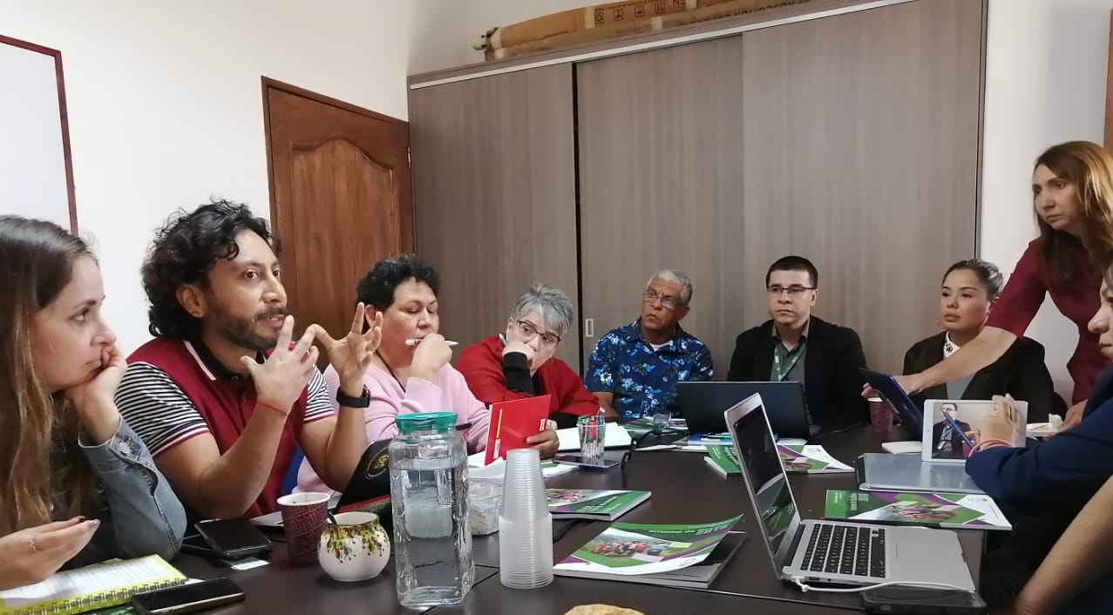

EXEMPTION FROM LIABILITY: This publication was produced for the United States Agency for International Development (USAID) and prepared by Social Impact, Inc., within the Civil Society Activity, Contract No. AID-OAA-I-13 -00045. The opinions and contents of this report do not necessarily reflect those of USAID or those of the U.S. Government.

TABLE OF CONTENTS

ACRONYMS AND ABREVIATIONS 4
EXECUTIVE SUMMARY 5
INTRODUCTION 7
Overview of the Civil Society Activity 7
DESIGN AND STRUCTURE OF THIS DOCUMENT 10
WHO IS THIS DOCUMENT FOR? 11
SECTION I 12
OVERVIEW OF CSA’S STUDY TOUR INITIATIVE: A LEARNING EXPERIENCE 12
WHY A STUDY TOUR? WHAT ARE THE BENEFITS? 12
SECTION II 15
STUDY TOUR METHODOLOGY 15
PHASE 1. DESIGN 15
PHASE 2. CALL FOR NOMINATIONS 17
PHASE 3. FIELDWORK 21
PHASE 4. DEVELOPMENT OF LOCAL PROJECTS 24
SECTION III 27
KEY OUTCOMES 27
LESSONS LEARNED AND RECOMMENDATIONS FOR REPLICATION 30

This white paper is part of a collection of strategic documents developed by the Civil Society Activity, implemented by Social Impact, Inc. and financed by the United States Agency for International Development (USAID). The texts that comprise the collection describe the systemic capacity development approach and methodology that the Civil Society Activity designed to accompany more than forty civil society organizations in institutional strengthening, grants management, and legal compliance. This document provides an overview of the Study Tour model that CSA designed and implemented with civil society leaders to exchange best practices, and highlights some of its key results. The full compendium of CSA documents is a useful resource for strengthening civil society organizations. You may reference the complete collection at Social Impact’s website, https://socialimpact.com
About the USAID/Mexico Civil Society Activity
USAID/Mexico’s Civil Society Activity (CSA) was a 4-year program funded by the U.S. Agency for International Development (USAID). CSA aimed to improve the sustainability of Civil Society Organizations (CSOs) to effectively implement their agendas on violence prevention, human rights protection, and justice reform in Mexico. To this end, CSA focused on improving CSOs capacity to communicate and work collaboratively, increasing their connections with key stakeholders, strengthening their capacity to develop strategies that respond to their changing environment and to their communities’ needs and priorities, and improving CSOs access to knowledge and resources. The USAID/Mexico Civil Society Activity was implemented by Social Impact (SI) Inc. in partnership with Fundación Appleseed.
About Social Impact
Social Impact (SI) is a management consulting firm that provides monitoring, evaluation, strategic planning, performance management, and capacity building services to advance development effectiveness. SI’s work helps to reduce poverty, improve health and education, promote peace and democratic governance, foster economic growth, and protect the environment. To achieve this, SI delivers consulting, technical assistance, and training services to government agencies, nongovernmental organizations, and foundations.
Acknowledgments
Study Tour Initiative: Model of Replication was a collaborative effort drawing on the experience and knowledge of numerous USAID and Social Impact staff. Special thanks go to the following individuals who contributed to the conceptualization and content of this document, and/or reviewed and provided comments on the document: Leonardo Escobar, Gladys Rivera and Lucila Serrano. Additional thanks go to CSA’s Brandon Fischer and Anne Largaespada for their leadership in curating CSAs knowledge.
Editorial coordination: Elise W. Storck
Authors: María Huerta Urías and Elise W. Storck
This publication was produced for review by the United States Agency for International Development. It was prepared by the Civil Society Activity (CSA) for USAID/Mexico Contract No. AID-OAA-I-13-00045. The authors’ views expressed in this publication do not necessarily reflect the views of the United States Agency for International Development or the United States Government.
Mexico City, 2020. All rights reserved by USAID or the U.S. Government. This document may be excerpted, photocopied, or adapted in whole or in part, provided the material is distributed free of charge and that credit is given to CSA and USAID.

ACRONYMS AND ABREVIATIONS

CD 2.0 | Capacity Development 2.0
CLA | Collaborating, Learning and Adapting
CSA | Civil Society Activity
CSO | Civil Society Organization
DO | Development Objective
HICD | Human and Institutional Capacity Development
ISO | Intermediate Support Organization
J2SR  MEL | Journey to Self-Reliance  Monitoring, Evaluation, and Learning
NUPAS | Non-U.S. Organization Pre-Award Survey
OCA | Organizational Capacity Assessment
OPI | Organizational Performance Index
SI  SNA | Social Impact  Social Network Analysis
TIER 1 | 28 CSOs that received Capacity Development support and Grants from CSA, which contributed to USAID’s Development Objectives
TIER 2 | 12 CSOs that are USAID partners in Mexico and received Capacity Development support
TIER 3 | 7 CSOs that received Grants to influence their performance on specific dimensions of the Civil Society Index
USAID | United States Agency for International Development

EXECUTIVE SUMMARY
This document describes the Study Tour Initiative, developed by the Civil Society Activity (CSA) implemented by Social Impact in the framework of its USAID/Mexico contract. The Study Tour Initiative was designed to provide eight Mexican participants from the states of Sonora and Coahuila with the opportunity to exchange knowledge, strategies, and networks for improved work in anti-corruption, violence prevention, and Rule of Law, through hands-on experience. The initiative included four phases as described below, including site visits to the cities of Medellín and Bogotá, Colombia from November 11-15, 2019. As a result of these activities, the Study Tour participants formed a Learning Community to help sustain their ongoing collaboration and learning.
This document describes the Study Tour Initiative and presents methodologies for replication, using CSA’s experience, results, and lessons learned. The Initiative incorporated all three objectives of CSA’s Capacity Development approach: 1) to strengthen civil society organizations’ (CSOs’) internal capabilities and processes; 2) to increase the ability of these organizations to develop and maintain strategic alliances with actors in civil society and other sectors; and 3) to strengthen the position of CSOs in the local systems in which they operate. The Study Tour emphasized the latter, systems-focused component, with the goal of strengthening the local system to support a strong civil society that works alongside other sectors to achieve sustainable results.
CSA designed the Study Tour Initiative based on the following three strategic principles:
- Strengthening the local system: The Study Tour strengthened the local system as it offered a unique, peer-to-peer learning opportunity that allowed foreign best practices to be examined, replicated, and scaled internationally, enriching participants’ vision of how to generate sustainable change in Mexico.
- Inclusion of geographically-linked local leaders: The Study Tour participants were local leaders who lived in the same Mexican states and towns, so that upon their return, they could consolidate and apply lessons learned from this experience to projects designed to have an impact on their local system, according to the social challenges they face together in their operating environment.
- Focus on alliances: The projects developed by the participants as a result of the Study Tour aim to integrate different sectors (private, public and organized civil society) to form collaboration networks and long-term alliances for sustainable change.
Utilizing these strategic principles, CSA designed a methodology consisting of four phases: 1) Design; 2) Call for Nominations; 3) Fieldwork; and 4) Consolidation of Local Initiatives. Each phase supported the goal of connecting and mobilizing local leaders from the states of Sonora and Coahuila with the necessary experience and influence to use the lessons learned from their Colombian hosts directly in own work in Mexico. In fact, upon their return, Study Tour participants consolidated two collaborative initiatives, designed for violence prevention. They consolidated these initiatives with an emphasis on sustainability from the outset, which entailed incorporating not only civil society actors, but other relevant sectors, such as the local government.

INTRODUCTION

Overview of the Civil Society Activity
USAID/Mexico designed the Civil Society Activity (CSA) to improve institutional capacities and increase the sustainability of civil society organizations (CSOs) in Mexico so they can more effectively implement their agendas related to crime and violence prevention, legal justice reform, and human rights. CSA supported three of USAID/Mexico’s Development Objectives: DO 1 on crime and violence prevention; DO 2 on access to justice; and DO 3 on human rights. Social Impact (SI), a development management consulting firm based in Arlington, VA, was the prime implementer of the CSA contract and designed the approaches described in this Strategy based on close collaboration with local partner organizations.
CSA’s Strategic Approach remained firmly rooted in the original capacity-building purpose, although upon receiving a contract modification on June 22nd, 2018, CSA expanded its intervention to emphasize systems-based strengthening, in addition to internal organizational capacity development, to sustain development results.
With an emphasis on improved organizational performance, rigorous assessment, the co-creation of solutions, systemic impact, and sustainability, CSA’s comprehensive approach was well aligned with USAID’s Journey to Self-Reliance (J2SR) and focus on measurable, increased local capacity. Thus, CSA provides a potential model for other USAID-funded capacity-building activities, as well as other capacity-building work, to enhance development impact and sustainability.
Figure 1. CSA’s Strategy for Sustainability of Results
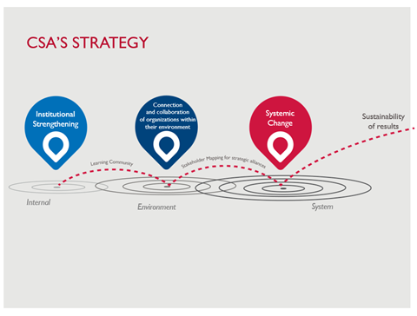
The Civil Society Activity implemented a systemic approach to capacity development across three primary components:
- GRANTS: Administer USAID grants awarded to civil society organizations to help them develop their thematic projects and capacity development initiatives.
- LEGAL STRENGTHENING: Provide technical support to improve legal compliance in areas of corporate, fiscal, and labor law; money laundering; and data privacy, through a network of pro-bono law firms based in Mexico, coordinated by CSA.
- INSTITUTIONAL STRENGTHENING: Accompany CSOs in developing their capacities in three ways—by improving internal capacities, strengthening abilities to create and sustain strategic alliances, and solidifying their positions within their Local Systems—based on an integrated methodology that incorporates Human and Institutional Capacity Development (HICD), Local Systems, and Capacity 2.0 approaches.

CSA implemented capacity development interventions with three groups of civil society organizations (CSOs), categorized in Tiers:

- TIER 1 was comprised of 28 CSOs that were awarded a USAID grant during the first year of CSA implementation. Three of these CSOs are Intermediate Support Organizations (ISOs)^{iv} that replicated grants administration and capacity development with fourteen CSOs who are their subgrantees. Organizations within this Tier received CSA’s full range of technical assistance to contribute to USAID’s Development Objectives.
- TIER 2 was comprised of twelve CSOs that were introduced to CSA by USAID/Mexico and its implementing partners. Tier 2 organizations took part in a modular assessment of organizational performance based in USAID’s Organizational Capacity Assessment (OCA), the Organizational Performance Index (OPI), Social Network Analysis (SNA), and Stakeholder Mapping. Tier 2 organizations then received technical assistance to improve their legal status, as well as performance solutions to address performance gaps identified during the assessment process.
- TIER 3 was comprised of seven CSOs and key actors who are influencers in Mexico’s civil society sector. These influencers will sustain CSA’s legacy in system strengthening by leveraging their areas of expertise to benefit civil society actors and their ability to collaborate within the system. These key influencers include actors who are known innovators, whether they be leaders of change, intermediaries across sectors, and/or key sources of information for the civil society sector.

Figure 2 provides a breakdown of the evolution of CSA’s approach to supporting the three Tiers described above.

Figure 2. Evolution of CSA
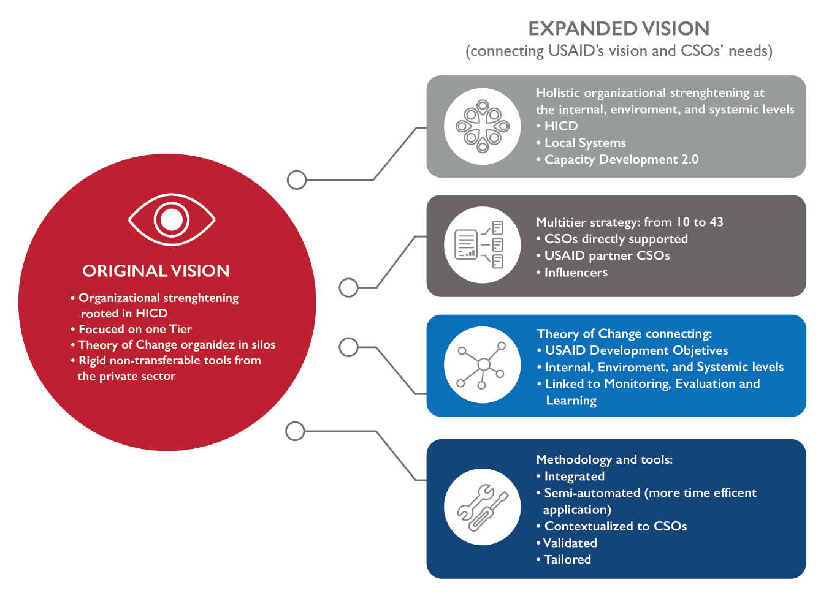

Social Impact based CSA’s original design on the HICD model. However, after becoming familiar with Capacity 2.0 at USAID and taking time to pause and reflect with partner organizations, CSA identified the need to expand its capacity development approach. Consistent with Collaborating, Learning, and Adapting (CLA), the CSA team began to propose additional components to the theory of change that would complement the original vision rooted in HICD, while drawing upon the latest best practices in the field. Inspired by the Local Systems and Capacity 2.0 approaches, the team began to focus on three aspects of organizational strengthening: strengthening internal capacities, strengthening relationships and networks in which organizations participate, and strengthening organizations’ positions within their Local Systems.

In a major conceptual and methodological shift, CSA expanded its understanding of organizational capacities beyond those that are internal to an organization by adopting USAID’s Local Systems framework. Based on this framework, CSA viewed each CSO as one of many actors within a system working around a given social issue. For individual CSOs and the CSO sector to have sustainable impact, it was crucial to develop their organizational capacities to interact, communicate, and collaborate, including with other diverse actors operating in the same system. In this way, CSA could more effectively support organizations as they tackled complex challenges in their environments.

DESIGN AND STRUCTURE OF THIS DOCUMENT
This document is designed to serve two related purposes: 1) to be an accessible knowledge resource to help readers understand the value and systemic impact of a Study Tour Initiative, based on the experience and lessons learned that CSA cultivated in collaboration with Study Tour participants; and 2) to serve as a practical guide to help donors and other key actors replicate the model successfully. Figure 3 below summarizes the document’s main content by section:
Figure 3. Content by Section

WHO IS THIS DOCUMENT FOR?
- For USAID/México and other funders to support, promote, and scale Study Tours as a mechanism to strengthen the Local System.
- For influencers and local leaders who seek to promote learning exchange between countries.

SECTION I

OVERVIEW OF CSA’S STUDY TOUR INITIATIVE: A LEARNING EXPERIENCE

CSA designed and convened the Study Tour Initiative to empower current and potential leaders and promote a collaborative learning experience that could contribute to strengthening Mexico’s civil society sector. By design, the Initiative was built around the notion that important systemic changes may occur if potential leaders who face similar constraints and share a high degree of commitment are invited to share a profound learning experience. Throughout the Initiative, participants also gained access to diverse capacity development tools and methodologies to expand their vision for social change. Moreover, the Study Tour Initiative aimed to connect participants with each other, and on their return, with other key actors in Mexico to increase their ability to collaborate in a challenging local system, in order to make their vision for social change a reality.

CSA designed the Study Tour Initiative based on three main principles:

- Strengthening the Local System: The Study Tour strengthened the Local System as it offered a unique, peer-to-peer learning opportunity to examine, replicate and scale best practices internationally, enriching participants’ vision of how to generate sustainable change in Mexico.
- Inclusion of geographically-linked local leaders: Study Tour participants were local leaders who lived in the same Mexican states and towns, so that upon their return, they could consolidate and apply the lessons learned from this experience to projects designed to have an impact on their Local System, based on social challenges they face together in their operating environment.
- Focus on alliances: The Mexican initiatives developed by the Study Tour participants aim to integrate different sectors (private, public and organized civil society) to form collaboration networks and long-term alliances for sustainable change.

WHY A STUDY TOUR? WHAT ARE THE BENEFITS?

CSA conceived the Study Tour Initiative to support its strategy of strengthening the Local System by connecting local leaders from the states of Sonora and Coahuila who have worked in the protection and promotion of human rights, peace culture, and transparency with Colombian CSOs and other actors with considerable experience in these fields. Fostering connection and collaboration between Mexican participants and local Colombian CSOs and or key actors enabled these leaders to identify and disseminate their best practices. Moreover, CSA supported participants in using a systems perspective to analyze how their experiences could promote collaboration among the group and with others, as well as to apply lessons learned in their everyday work.
Engaging local civil society leaders in a hands-on Study Tour Initiative is an investment that pays off in multiple ways, as follows:
- Rapid investment in priority subject areas: Participants were chosen based on their work, expertise, and leadership in peacebuilding, human rights, and transparency. The Study Tour enabled participants to share knowledge and increase systemic impact in these priority subject areas.
“One example is the synergy achieved between civil society, government, and the beneficiary population in building models based on previous work to strengthen their own organizational capabilities.
Alberto Xicotencatl, participant.
- Greater impact as a result of investing in groups: Rather than investing in individuals, the Initiative aimed to consolidate a group of committed and experienced people who would collectively contribute to the prioritized areas.
- Potential to propel change in the short term: The results of the Study Tour were expected to be visible in the short term, because the lessons learned could be applied as soon as the participants returned to Mexico.
- Consolidation of alliances between diverse sectors: CSA understood that it is more feasible to consolidate new alliances among key influencers (both during their time in Colombia and upon their return to Mexico) if participants understood and agreed with the objective of increased collaboration. The Study Tour provided the visiting leaders and their hosts with a facilitated space in which to forge new opportunities for collaboration and it built the foundation for sustainable alliances between sectors.
- Investment in people who can lead change within their institutions: The Study Tour enabled key actors and influencers to apply lessons learned by their peers – fellow leaders working on similar challenges – to their own work in their respective institutions (CSOs, government areas, or private initiatives).

WHO PARTICIPATED?
Based on selection criteria that included leadership and collaboration potential as described in detail below, CSA selected eight participants (four from Sonora and four from Coahuila). After a process of vetting and sensitization, the group traveled to Medellín and Bogotá, Colombia with two CSA staff for South-South, peer-to peer knowledge transfer with five Colombian colleagues working in peacebuilding, human rights and transparency. After their return from Colombia, participants collaborated in forming a Learning Community that resulted in the design of two local initiatives in Mexico with a Local Systems approach.

SECTION II

STUDY TOUR METHODOLOGY
CSA staff realized that to be successful, the Study Tour should not only provide participants with a valuable experience traveling to Colombia and learning from key actors there, but that Mexican participants would also need to obtain tools and expertise to transform these learnings into a viable project in Mexico. Thus, CSA designed a four-phase methodology focused on sustainability and development impact. Each phase incorporated specific CSA strategies and principles, such as an emphasis on Local Systems and alliances.
This section explains the four phases to support replication of CSA’s model. Each phase includes the processes and approach, as well as recommendations for replication.
Study Tour phases:
- Design
- Call for Nominations
- Fieldwork
- Project Consolidation

PHASE 1. DESIGN

CSA’s design methodology emphasized clarity about the objectives for CSA and eventual participants alike, as well as defining the thematic areas of interest and participant selection criteria. All aspects of the methodology used a Local Systems perspective, to ensure the sustainability of the collaborative work that participants would deliver upon their return. The design phase also included defining host country characteristics and the communication strategy. CSA staff developed Phase 1 activities concurrently rather than sequentially, which became one of the most practical aspects of the Initiative.
DEFINING OBJECTIVES: The Study Tour aimed to facilitate knowledge transfer and peer- to-peer learning, provide capacity development tools for participants, and establish the expectation that the Mexican participants would form alliances and joint initiatives to sustain the Initiative’s impact. To achieve these objectives, the Initiative included a combination of discussion sessions, hands-on exchanges at host organizations, and site visits to host projects. Upon their return, participants contextualized the lessons learned and applied them to a local initiative in Mexico or in their own institutions and organizations. To ensure the sustainability of these projects, CSA provided resources and expertise on key issues such as alliance building and systemic impact.
TOPICS OF INTEREST: Defining the Study Tour’s areas of interest entailed identifying local challenges that are shared by both countries, as well as the thematic interests of the sponsoring program. Sufficient commonality needed to exist in terms of challenges, key types of actors, and operating constraints, so that the lessons learned could be transferred. Based on these criteria, CSA’s Study Tour focused on peacebuilding, human rights and transparency, which are directly related to the funder, USAID/Mexico’s, Development Objectives and similarities between Colombia and Mexico in these thematic areas.
LOCAL SYSTEMS FOCUS: USAID’s Local Systems approach informed all phases of the Study Tour methodology. This included engaging the participation of multiple actors, from the design of the Study Tour until its completion, with the objective of strengthening the local system.
PARTICIPANT PROFILES: CSA selected participants based on the following criteria and characteristics:
- Work experience
- Role in strengthening their Local System
- Capacity to influence or lead change
- Knowledge about the prioritized Study Tour themes
- Shared geographic location of their projects, i.e., in Sonora and Coahuila
- Willingness to collaborate and be part of a new Learning Community on their return
In addition to identifying common geographic work locations, CSA recommends that participant selection be based on analysis that includes stakeholder mapping with allied CSOs. CSA performed this mapping to favor zones where new collaboration between important actors and influencers from different sectors could be launched. In addition, CSA aligned with USAID/Mexico’s priority to invest in activities that empower leaders whose work advances the Journey to Self-Reliance and contributes to the Mission’s DOs.
COUNTRY TO BE VISITED: CSA identified the host country at the beginning of the Study Tour design process, based on two criteria: 1) There were identifiable and accessible CSOs, influencers, and other actors with considerable local experience in the Study Tour areas of interest (i.e., peacebuilding, human rights and transparency); and 2) it was possible to design and organize a trip to this country, taking into account factors such as security, country risk, socioeconomic stability, and any other characteristics that might affect optimal implementation of the Initiative.
CSA chose Colombia because of its similarities with Mexico in peacebuilding and violence prevention. In Colombia, the drug cartels deeply impacted the country’s social fabric, as has recently happened in Mexico. In response to the crisis, Colombian influencers and stakeholders (i.e., civil society and other actors) redefined what citizen engagement can mean, resulting in social interventions that have long outlasted the war against the drug cartels. Because of the parallels between the two countries, CSA identified key Colombian stakeholders among CSOs and other actors who could transfer their best practices and knowledge to Study Tour participants by hosting them in their places of work.
COMMUNICATION STRATEGY: CSA designed a Communication strategy to clearly convey the Study Tour objectives, as well as the relevance of the Initiative to the stakeholders and their specific role within the project. For example, CSA developed specific Study Tour materials for the host organizations and actors in Colombia in addition to materials for the Mexican CSOs and individual participants. Additionally, communication materials such as infographics were designed to provide participants with the most relevant information about each Colombian organization to be visited. Figure 4 provides an example of Study Tour communications.
Figure 4. Example of communication material to explain the Study Tour learning process
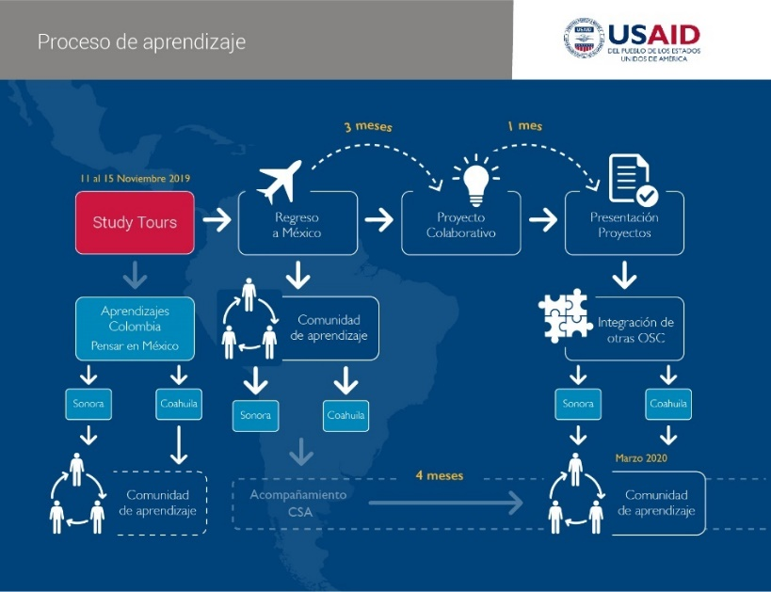

PHASE 2. CALL FOR NOMINATIONS

Phase Two entailed identifying the best possible Study Tour participants. As noted, to provide this learning opportunity to current and future leaders who would make the most of it, CSA invited allied CSOs to nominate individuals whom they believed met the profile specifications. This helped ensure the nominated individuals were already recognized by CSOs in their field of work; this approach also strengthened the Local System by vesting allied CSOs in the success of the Study Tour, as well as the follow-on projects to be jointly designed and implemented by participants. The CSO nominations provided a first “filter” to make the best selection possible.
PARTICIPANT PROFILE AND SELECTION CRITERIA: The selection process began with CSA’s inviting allied CSOs to nominate individuals from Sonora and Coahuila with a known trajectory of leadership in promoting human rights, peace culture, and transparency. Participants could work within civil society or other sectors, such as the private sector or local government. Nomination criteria were based upon the individuals’ previous work, potential for increased leadership, and willingness to collaborate. Involving allied CSOs in the selection process provided CSA with greater insight into the concerns and operating environment of local actors in both states and helped ensure participants could sustain and expand their collaboration upon their return. Figure 5 depicts the announcement used to invite nominations for the Study Tour.

Figure 5. Study Tour Call for Nominations

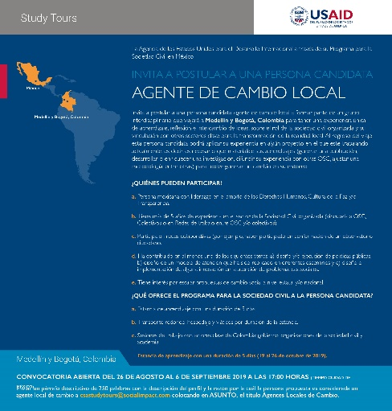

FOCUS: In addition to the selection criteria, three important principles guided CSA’s decision-making process:
- Inclusion: CSA was deliberate in seeking candidates with diverse profiles, including different backgrounds, education, ideology, religion, sex, ethnic identity, and socioeconomic context, among other demographic factors.
- Equality: CSA committed to provide this opportunity to everyone who met the selection criteria and ensured the process was equal for all nominees, without giving preference to any candidate.
- Systemic Impact: The profile of each proposed candidate helped ensure the initiative they would help develop on their return could have a systemic impact.
SELECTION PROCESS: To ensure a transparent, unbiased selection process, CSA convened an internal Selection Committee composed of five CSA staff with different professional profiles. Based on their experience and background, each member utilized the selection criteria and the documents listed below to make their choice. CSA recommends that the selection process be formally documented, to include the following information:
- A candidate evaluation document for each candidate completed by all members of the Selection Committee. The form contains the selection criteria and enables Selection Committee members to assign a score for each criterion.
- A letter signed by each Selection Committee member assuring there are no conflicts of interest in terms of their relationships with the candidates or the organizations for which the candidates work.
- A letter signed by each Selection Committee member stating they will not disclose personal or sensitive information.
- A selection memo describing the number of nominations received and the number of candidates who were selected, aligning selected applicants to the established criteria.
The CSA Selection Committee held a formal meeting to assess the nominations made by allied CSOs. A Committee Chairperson provided the committee with the instructions and criteria to ensure rigor and fairness. Committee members assigned numerical scores using the template found in Figure 6 below.
Figure 6. Template for selection process
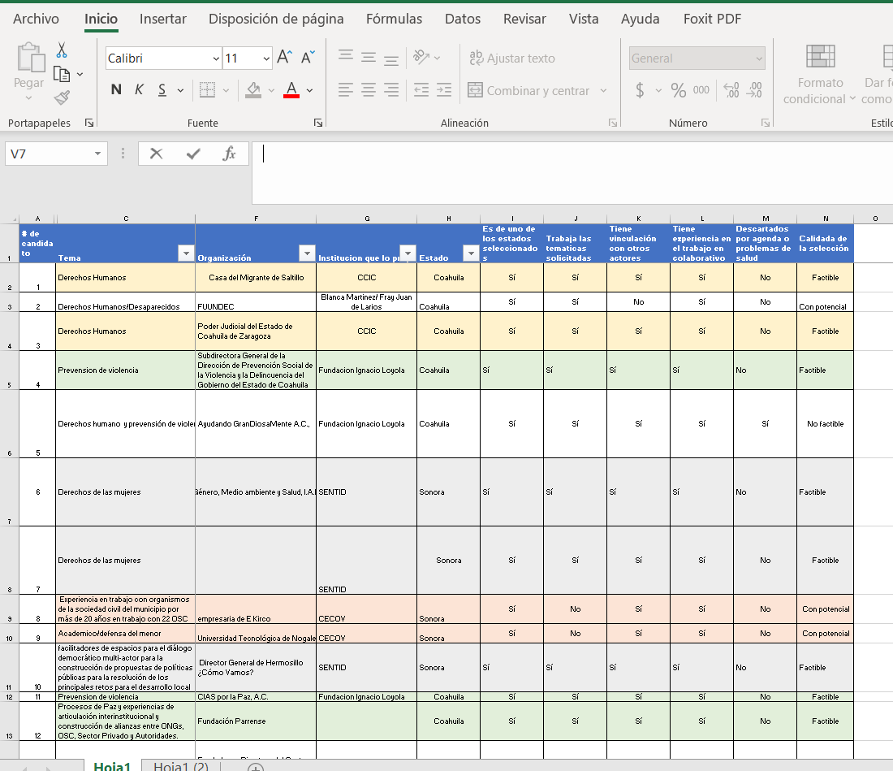

Table 1 lists the eight selected participants, their work location, work experience, and contribution to the Study Tour.
Table 1. Study Tour Participants
Name | State | Work experience | Study Tour Contribution
Inés Guadalupe Martínez de Castro Navarrete | Sonora | - Professional experience in gender and public policy.  - Active promoter/advocate of women’s rights.  - Founding member and president of the CSO “Género, medio ambiente y salud” (Gender, environment, and health).  - Member of the Women´s Committee in Sonora since 1998. | - Expertise in Women’s Rights  - Integrated the gender perspective throughout the Study Tour.  - Introduced gender issues in peacebuilding and Human Rights.
Ernesto Urbina Miranda | Sonora | - CEO of the citizen-led initiative “Hermosillo ¿Cómo vamos?” a network of CSOs and private sector actors that collaborate to propose better public policy for Sonora.  - Director of ETHOS a CSO specialized in public policy lobbying. | - Incorporated the private sector’s interest and role in Peacebuilding, Human Rights, and Transparency.
Ángel Gabriel Hernández Guzmán | Coahuila | - Auxiliary Secretary for the Human Rights Unit within the Justice System in Coahuila.  - Lawyer and teacher. | - Introduced a judicial authority perspective on Human Rights issues and the challenges and opportunities for collaboration between public authorities and CSOs.  - Provided expertise on Transparency and Accountability issues.
Claudia Lisette Méndez | Coahuila | - Lawyer  - Deputy Director of the office for the Prevention of Violence and criminal behavior in the State of Coahuila. | - Promoted the design and use of public policy for peacebuilding and the reduction of violence through the justice system.
Alberto Xicoténcatl Carrasco | Coahuila | - Vast experience in the protection and promotion of Human Rights.  - Director of “Frontera con Justicia” and other projects that protect migrants’ Human Rights. | - Introduced and promoted the Human Rights perspective throughout the Study Tour.
Óscar Daniel Torres Rosales | Coahuila | - Researcher in a Jesuit led CSO, “Acción Social Jesuitas por la Paz.”  - Expert in initiatives that aim to rebuild the social bonds and structures of a peaceful society. | - Provided insight and extensive knowledge on Human Rights and inclusive peacebuilding processes.
Martha Patricia Alonso Ramírez | Sonora | - Expert in social work and promoter of indigenous communities in the state of Sonora.  - Founder of the civil grass-roots movement for the promotion of indigenous women’s rights “Mujeres Lucha.” | - Provided insight into the relevance and value of grass-roots community based social movements for the promotion and protection of Human Rights.
Sara Velarde Castro | Sonora | - Expert in CSO funding.  - Responsible for procurement in the CSO, “Fundación Parrense DIM.” | - Introduced issues and solutions related to CSO sustainability and the importance of alliances with other key sectors.

PHASE 3. FIELDWORK

Phase three of the Study Tour methodology entailed defining the itinerary for Colombia fieldwork. CSA used a three-step process to identify host organizations for the site visits, contact and orient them to the Initiative, and collectively design all the group activities. Figure 7 depicts this process, which is described in greater detail below.
Figure 7. Three-step process to define the fieldwork Itinerary
- Stakeholder Mapping: Identification of CSOs, public sector actors whose work or experience directly related to the areas of interest, private sector actors who are involved in this type of work, and other key actors, such as international cooperation agencies.
- Selection of host organizations in Colombia: CSA contacted those organizations that had an ideal profile. This included sending a description of the Study Tour Initiative and requesting an opportunity to discuss the contact’s potential participation as a host organization and project site. Table 2 lists the names, locations, and focus areas of the Colombian host organizations:

Table 2. Colombian host organizations and focus areas

Name of the Organization | focus areask
- Transparencia por Colombia | The organization responds to a complex political environment, where there have historically been high levels of corruption at the public level, ultimately weakening democracy. This organizations leads the fight against corruption and advocates for transparency in the public and private sectors.
- Viva la Ciudadanía | Viva la Ciudadanía integrates the work of eight CSOs that work together to strengthen democracy in Colombia by working through civil society organizations as key actors to promote transparency.
- Prodepaz | The organization works to promote and strengthen regional development through coordination between public institutions and communities, to strengthen democracy and reach peaceful living conditions for all citizens.
- Fundación Ideas para la Paz | This organization was created by private sector actors to generate knowledge, propose initiatives, develop practices, and follow through processes of peacebuilding that are sustainable in Colombia. They also seek to understand the origins of conflict in Colombia.
- Centro de Investigación y Educación popular | This organization focuses on the systemic production of trustworthy information and the consideration of popular education systems to strengthen civil society organizations and communities.
- ACDI/VOCA | This is a North American organization that promotes the development of initiatives and opportunities to increase livelihoods. In Colombia, ACDI/VOCA led a USAID-funded activity to promote peacebuilding in communities affected by the war against the guerrillas in different regions.

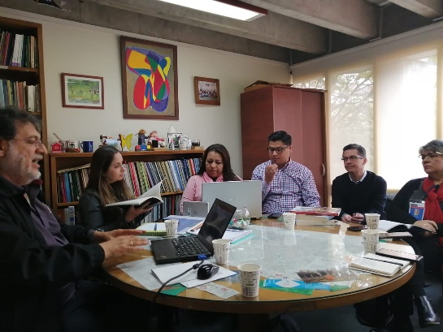
- Joint definition of activities and agenda design After the host organizations agreed to be part of the Initiative, it was important that they jointly define the agenda of the in-country visit. CSA facilitated a virtual meeting with each host organization, to identify the most valuable Colombian experiences and best practices related to the Study Tour focus areas. It was also important to cultivate a space for the exchange of ideas and opinions, so that participants could take full advantage of the interaction. During this stage, a joint decision was made on the date, time and duration of the visit. CSA repeated this process with all the host organizations to be visited. In addition, CSA staff consolidated a repository of information and resources for participants to consult and research. This repository was compiled in an open access cloud service and was accessed by participants prior to the trip. Figure 8 depicts the 5-day Study Tour Agenda developed jointly with the host organizations.
Figure 8. Study Tour Agenda to Medellín and Bogotá, Colombia

PHASE 4. DEVELOPMENT OF LOCAL PROJECTS

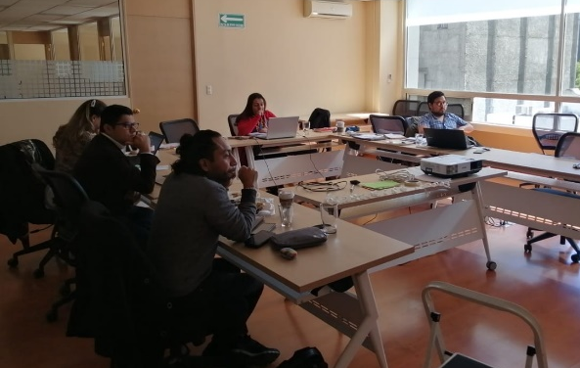
Phase Four entailed Mexican Study Tour participants developing joint projects to respond to social challenges in Sonora and Coahuila. The participants began this collaboration by forming two groups: The first group was formed to develop a project to respond to gender violence in the state of Sonora; the second was established to respond to gender and other types of violence in Coahuila. In order for both groups to consolidate their local project ideas, CSA facilitated several capacity development sessions to strengthen the project designs and guide them towards a Local Systems perspective. Annex 1 describes both projects in more detail.
CROSS-CUTTING CAPACITY DEVELOPMENT TOOLS: CSA used cross-cutting tools to advance its strategy to strengthen the Local System and key actors’ ability to successfully implement their agendas. Two of the cross-cutting tools with particular relevance to the Study Tour Initiative were Alliances and Monitoring, Evaluation, and Learning (MEL).
ALLIANCES: As the culmination of the Study Tour initiative, Phase Four consolidated the lessons learned and included alliance-building for joint project development. This Phase represents the integration of the Study Tour group with other local or nationwide collaboration networks, as well as formalizing nascent alliances with specific actors in the Local System with an influence over the success of the local project.
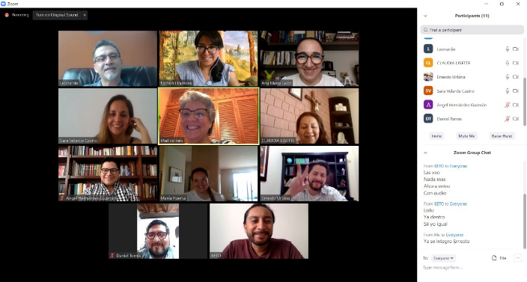
MONITORING, EVALUATION, and LEARNING:
CSA used a variety of MEL tools to monitor the Study Tour, measure its impact, and use learning and adaptive management to adjust the approach. The following key processes were utilized:
- Design and application of quantitative and qualitative surveys to compile the opinions and experiences of participants:
  - Quantitative satisfaction surveys to compile participants’ opinions about the development of the initiative
  - Quantitative knowledge surveys to compile lessons learned from each Study Tour activity
  - Qualitative survey with an open question format to elicit participants’ opinions and perceptions
  - Additional interviews to compile participants’ viewpoints and experience
- Measurement system and indicators: Identification of methodology and classification of principles used to rate the qualitative answers (number of mentions) and associate them with each category in the methodology.
CSA facilitated six capacity development sessions with the Study Tour participants, which included MEL and other topics. These meetings identified the goal and objectives of the project, its theory of change, measurement indicators to track the achievement of project objectives and the alliances and clear roles and responsibilities among participating individuals and organizations that are required to consolidate their projects. Table 3 depicts the capacity development sessions that CSA facilitated with Study Tour participants:
Table 3. Capacity Development Sessions facilitated by CSA

CONSOLIDATING A STUDY TOUR LEARNING COMMUNITY:
CSA established two Learning Community groups as a systems-focused intervention based on CLA. Each Learning Community was composed of partner organizations and local leaders who collaborate and learn from each other by discussing topics of mutual interest; clarifying operational and programmatic questions; and sharing lessons learned on capacity building and other topics. In addition to informing member organizations’ work and helping to improve their internal performance, Learning Communities strengthen the broader system by reinforcing existing relationships, establishing new linkages among member organizations, and pointing to new alliances and opportunities for collaboration in the Local System. Within this framework, Study Tour participants were also expected to form a Learning Community, consistent with the selection criteria’s emphasis on collaboration.
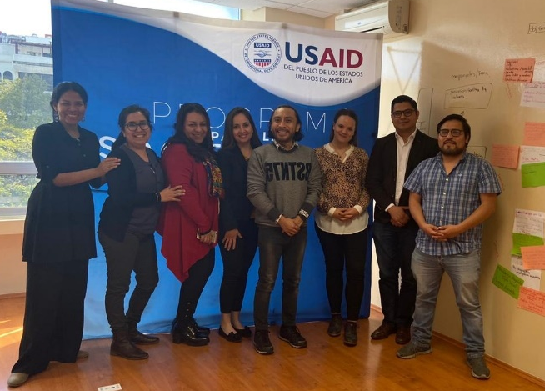
The goal of the Learning Communities was for organizations to strategize together and collaborate, integrating the capacity development assets and Local Systems approach that CSA facilitated during the four-year USAID contract. The Study Tour to Colombia, including all the site-visits and activities with local hosts, lessons learned, and best practices, nurtured the establishment of Learning Communities that, in turn, shared their experience with the other CSA Learning Communities. CSA invited the Study Tour participants to participate in the last of the Learning Community events facilitated by CSA and allied CSOs in February 2020. At the session, Study Tour participants shared their experience in Colombia, as well as the local projects they were developing for implementation in Sonora and Coahuila.
“The vision of the organization we visited about the importance of strengthening civil society as a builder of citizenship clearly favors equality, the eradication of poverty, peace, and citizen coexistence.”
Claudia Lisette Santana, Study Tour participant.

“Placing civil society and its work in the public eye, putting peacebuilding and human rights on the public agenda, and effective use of methodologies with an anticorruption focus, are important benchmarks for our work.”
Angel Hernandez, Study Tour participant.

SECTION III

KEY OUTCOMES
“The experience of visiting Bogota and Medellin was enriching. Discovering civil society’s profiles for action and its collaboration with academia and government allowed me to identify the key to success in implementing peace-building strategies: intersectoral collaboration.”
Participant in the Study Tour to Colombia.
The Study Tour contributed to the empowerment and capacity development of local leaders who have worked together in two significant ways since their return from Colombia: 1) institutional collaboration among participants and their respective organizations; and 2) the design and launch of two joint projects aimed at violence reduction in Sonora and Coahuila.

INSTITUTIONAL COLLABORATION BETWEEN PARTICIPANTS: As described above, the Study Tour methodology provided participants with concrete, contextualized examples of how civil society and other actors in Colombia have responded to social challenges that share many similarities with those currently faced by Mexico, particularly around peacebuilding, human rights, and transparency. These experiences equipped participants with examples and best practices that have enabled them to establish institutional collaboration and design joint local projects.
This section synthesizes the Initiative’s most significant outcomes. These outcomes reflect that the Study Tour Initiative was not only a one-time, collaborative activity, but that it catalyzed numerous types of collaboration among the participants and with other actors, which contribute to strengthening the civil society sector and its strategic position with other sectors.
Table 4 systematizes the most significant outcomes of institutional collaboration.
Table 4. Significant outcomes of institutional collaboration between Study Tour participants
outcome | description
PEACEBUILDING: institutional Alliances between Study Tour participants | Study Tour participants Sara, who works in a CSO and Angel, who works in the Justice branch of the Government of Coahuila, have established an alliance so that CSOs (including Sara’s) can receive training on judicial due process. This alliance has established an unprecedented form of collaboration between a CSO and a government agency in the state of Coahuila.
human rights: RESTRUCTURING THE PREVENTION OF VIOLENCE IN THE STATE OF COAHUILA | Claudia, who leads the Department for the prevention of violence within the judicial branch in Coahuila, has incorporated various thematic schemes, such as gender and migration, and has invited Alberto, a specialist in the protection and promotion of migrants’ Human Rights, to collaborate. Their collaboration and peer-to-peer knowledge exchange has resulted in an improved framework for the prevention of violence in the state of Coahuila.
HUMAN RIGHTS: covid-19 collaboration | Ernesto, who works with the private sector in Sonora, has established a support network to provide humanitarian assistance to the most vulnerable communities in the state. In collaboration with Inés, who works with indigenous communities and has extensive knowledge of grass-root organizations, they have identified the best means of reaching the people who are most in need and have established an unprecedented collaboration between the private sector and grass-roots movements.
PEACEBUILDING: local system approach for Multi-sector collaboration | Daniel, who is the lead researcher in CIAS por la PAZ, a Jesuit-led organization, has incorporated the best practices he identified in the Study Tour to Colombia in his own organization. For example, he identified the importance of multi-sector collaboration in the peace-building process. Daniel also provided his colleagues with insight into the importance of the Local System and how a systems-based response can better rebuild the social fabric, rather than disparate, isolated efforts.
TRAnsparency: COLLABORATION BETWEEN LEARNING COMMUNITIES FOR THE PREVENTION OF VIOLENCE | Ernesto reached out to Sentit Nobis, a CSA allied organization that is part of another Learning Community group to build an alliance for violence prevention. The alliance also supports citizen engagement to promote government transparency. This collaboration between CSA allies was possible due to the presence of Study Tour participants at a CSA Learning Community event.

JOINT PROJECTS: As mentioned in Sections I and II, Study Tour participants were expected to develop and implement a joint project to address local challenges in their state. These projects were to be designed using the best practices and peer-to-peer knowledge obtained in Colombia. Study Tour participants designed two such projects, one in the state of Coahuila and the second in Sonora. CSA’s expectation was not that these projects would be operational within the life of the CSA contract, but rather that participants would have the capacity development tools to design and establish the framework for each joint initiative. Table 5 depicts the most significant outcomes that Study Tour participants achieved nine months after their return from Colombia during the time period from November 2019 to August 2020.
“If we can achieve a process of real dialogue, we can reach the level of trust needed for reconciliation and peace. Working for peace requires transforming local communities Peace reduces insecurity and improves living conditions.”
Martha Patricia Alonso

Table 5. Significant outcomes of the Local Projects
project | description and main outcomes
“construyendo paz por coahuila” (building peace for coahuila) | Description: “Building Peace for Coahuila” is a collaboration between Study Tour participants who live and work in Coahuila. This project was designed to promote multi-sector collaboration to address gender-based violence in the state.  Goal: To contribute to the prevention, prosecution, and eradication of violence against women through the prevention, procurement, and administration of justice, providing focused and comprehensive attention to the security of women of the State of Coahuila.  Main outcomes:  - A communications strategy on gender and Human Rights including media campaigns that highlight the need for social and institutional commitment to recognize, prevent, and end violence against women who live in or travel through Coahuila.  - A plan to consolidate strategic alliances between public and private sector organizations and organized civil society to fortify comprehensive attention to a gender policy in Coahuila.  - Provision of behavioral and cognitive tools and resources to government officials to offer empathetic and quality attention to citizens on topics of gender and Human Rights.  - An awareness program about the implications of inequality between men and women, and gender-based violence caused by traditional ideas of masculinity, taught through games and other dynamics.
“ALIANZA PARA LA PREVENCIÓN DE LA VIOLENCIA DE GÉNERO EN SONORA”  (alliance for gender-based violence prevention) | Description: “Alianza para la prevención de la violencia de Género en Sonora” is a collaboration between Study Tour participants who live and work in Sonora.  Goal: This project was designed to promote a coordinated response to sensitize communities about the degree of violence against women in their region.  Main outcomes:  - Study Tour participants have designed the theory of change and expected results of this project.  - The group has had on-line sessions to determine other partnerships that could be consolidated in order to advance the objective.

LESSONS LEARNED AND RECOMMENDATIONS FOR REPLICATION

During an international Initiative of this nature involving many different types organizations, changes constantly occur. This requires flexibility, humility, openness to learning, and a willingness to adapt. In this sense, the Study Tour Initiative to Colombia became a Collaborating, Learning, and Adapting experience that required ongoing Change Management for CSA and SI staff. Table 6 depicts lessons learned and practical recommendations for replicating this model.
Table 6. CSA’s Lessons Learned and Recommendations for replication
DESIGN | - CSA recommends that practitioners take into account the context of the country to be visited in order to define the Study Tour’s thematic focus. This implies validating the selected topic with experts and consulting different sources.  - An additional good practice is to prepare communication content that clearly explains Study Tour objectives, selection criteria, and expectations. Communication approaches such as video and social media can be used to broadcast these guidelines.
CALL FOR NOMINATIONS | - The call for nominations process allowed CSA to consider the expert opinion of allied CSO’s for better participant selection. This allowed CSA to consider people with a recognized work trajectory and known leadership in the thematic areas of the Initiative. For replication, CSA recommends that Study Tour practitioners consider the criteria of other allies to enrich the selection process.  - CSA learned that the call for nominations should require that candidates share similar professional objectives related to the thematic focus, as well as work in the same, specified geographical area. These two characteristics support systemic change and allow more efficient and sustainable design and implementation of local projects.  - From the outset, communicate work expectations and the future level of effort implied by the design and implementation of joint projects.  - CSA also learned the value of signing a letter of commitment with participants that specifies these work expectations and anticipated time required to develop a local project after their return.
FIELDWORK | - CSA recommends that conveners ensure that participants’ interests coincide with the agendas and working models of the organizations and/or institutions to be visited.  - Conduct a preliminary visit to the host organizations and/or institutions before the Study Tour to acquire in-depth knowledge of their work and clarify their understanding of the Study Tour purpose.  - CSA quickly learned the importance of designing working sessions and learning platforms to transfer capacity development tools, such as project design, theory of change, and a focus on alliances, so that participants analyze their lessons learned using the Local System approach.  - Developing a simple template with reflection prompts and questions allows participants to document and analyze their lessons learned each day. This template supports individual reflection and is also the basis for daily review and discussion with the other participants.  - Holding a wrap-up meeting at the end of each day enables the group to share, examine, and consolidate the most important lessons generated by participants. These may be curated on two levels:  - Individually: Reflection on how the lessons will contribute to the participant’s professional development, as well as to the capacity of the organization or institution where the participant works.  - Collaboratively: Recognizing that the Study Tour group is a Learning Community, reflection on how this new knowledge can support building the joint projects with an impact on the Local System in which the participants work.
POST-STUDY TOUR | - For the purposes of sustainability and to continue to strengthen the Local System, CSA recommends follow-up activities after the Study Tour. CSA learned that the call for nomination should establish their institutions’ commitment that participants will have the necessary resources and time to apply their knowledge into the local project.  - Provide the Learning Community with practical design and MEL tools so they can manage the local initiatives and ensure they are successful and sustainable. This also entails providing technical support and working meetings for project design and sustainability.  - CSA recommends specific actions to strengthen participants’ capacities, such as:  - Help participants use a Local System focus to identify different levels of impact.  - Recognize that participants have worked primarily with an internal focus (peer-to-peer knowledge and capacity development for their organizations). Support them in socializing this knowledge externally through broader networks and alliances to help others advance and use collective knowledge.  - Leverage the organizational profiles of group members to support ongoing, collective learning and project design.  - To increase ownership and sustainability, as well as strengthen their Learning Community and Local System, encourage participants to design and facilitate their own meetings upon their return, without the presence of the convening authority. Self-governance will help ensure the joint work is appropriate to local needs and reflects participating organizations’ priorities.  - The convening authority may, however, serve as an “honest broker” providing guidance for the Study Tour participants to formalize alliances among the group and other key stakeholders, as well as provide comments or suggestions on the design of the collaborative project.  - The extent to which the two groups were able to design and launch joint projects differed. CSA recommends that practitioners consider the following two lessons learned related to joint projects:  - A leader from each geographic group needs to step forward to help encourage and model collaboration. The Study Tour convener should help identify leaders who might take on this role.  - Organizations involved in peacebuilding, human rights and transparency are already stretched and face tremendous obstacles and even danger in their work. Taking on an additional joint project may not be a priority for participants, given competing demands. Thus, the Study Tour convener should attempt to schedule a study tour earlier in the life of their activity. This will enable the convenor to provide more support for joint project design and implementation after participants return.

“This experience has given me, personally, and the organization where I work some very valuable lessons. The selection of the Study Tour participants was very fitting as it has led to lots of opportunities for collaboration, integrating actions from the platforms in which each of us work.”
Leader of change of Coahuila, participant in the Study Tour to Colombia.
“The experience of the Study Tour left me with extremely valuable lessons for understanding Mexico. From the painful experiences of Colombian society that has refused to forget the atrocities committed by a few actors, arose a generation of people who demand public policies of justice, non-reoccurrence, and reparation of damage – all of which are really needed in our country.”
Leader of change of Coahuila, participant in the Study Tour to Colombia.

USAID. (2014). Local Systems: A Framework for Supporting Sustained Development. Accessed on July 27. 2020. https://www.usaid.gov/policy/local-systems-framework
USAID (2011). Accessed July 27, 2020. Human and Institutional Capacity Development Handbook: A USAID model for sustainable performance improvement. https://usaidlearninglab.org/sites/default/files/resource/files/HICD%20Handbook%202011%20-%2008.pdf.
USAID. (2014). Local Systems: A Framework for Supporting Sustained Development. Accessed on July 27. 2020. https://www.usaid.gov/policy/local-systems-framework
USAID. (2017). Capacity 2.0. Accessed on July 27, 2020. https://usaidlearninglab.org/library/capacity-20
USAID. (n.d.) “CLA Toolkit.” Accessed July 27, 2020. https://usaidlearninglab.org/cla-toolkit
USAID. (2014). Local Systems: A Framework for Supporting Sustained Development. Accessed on July 27. 2020. https://www.usaid.gov/policy/local-systems-framework
https://www.usaid.gov/sites/default/files/documents/1862/USAID-Mexico-CDCS-with-Addendum-1-as-of-Nov-2015.pdf

