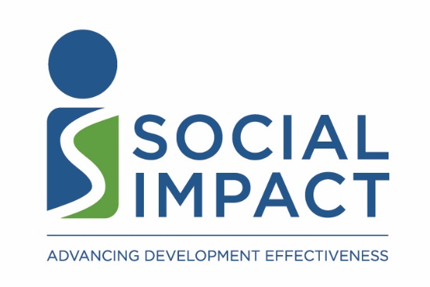

Request for Proposal
for
Legal Services in Kenya

Submission of Proposal Deadline: Monday, September 14th, 2020, 5:00pm EST.

Inquiries and proposals should be directed to:
Title: | Director of Business Operations
Name: | Mr. Steve Thomas
Email: | sthomas@socialimpact.com  cc:  Ms. Laura Raymond, lraymond@socialimpact.com  Ms. Rebecca Lawrence, rlawrence@socialimpact.com  Ms. Alex McMullin, amcmullin@socialimpact.com;
Address: | Social Impact, Inc.  2300 Clarendon Boulevard, Suite 1000,  Arlington, VA 22201, USA

Legal Services in Kenya
Specifications

Background

Social Impact (SI) is a Washington, DC-area international development management consulting firm. SI’s mission is to improve the effectiveness of international development programs in order to improve people’s lives. We provide a full range of management consulting, technical assistance, and training services to strengthen international development programs, organizations, and policies. We provide services globally in the areas of monitoring and evaluation, strategic planning, project and program design, organizational capacity building, and gender and social analysis. SI services cross-cut all development sectors including democracy and governance, health and education, the environment, and economic growth. SI’s clients include US government agencies such as USAID, the Millennium Challenge Corporation, and the US Department of State; bilateral donors; multilateral development banks; foundations; and non-profits.
SI’s official home page is: http://www.socialimpact.com/

- General Information

  - Purpose: This Request for Proposal (RFP) is to contract for legal services to be provided to SI’s field office in Nairobi, Kenya on registration activities starting from September 2020. The project will be active until October 2021.

  - Staff and Office: SI expects operations in Kenya to consist of a staff of 2, working from home temporarily, until staff can safely conduct operations from the prime contractor’s field office in accordance with local COVID-19 safety measures. Staff hired include one local national and one US national.

  - Activities: SI’s activities in Kenya will exclusively center on providing support to the USAID Kenya mission.

  - Funding: Funding for the operations will come from SI’s headquarters in the United States. We do not anticipate any fundraising or profit-making activities in the country.

- Scope of Service Required

  - Registration-related work for the organization to have a legal presence in Kenya:

- Assessing the need for registration given our activities and level of presence
- Explaining the options available and the advantages/disadvantages of each option
- Detailing the process and costs for each option with time estimates
- Recommending an option and including information for the first 4 bullets under 2.1 in a registration pre-decision memo for Social Impact as the first deliverable (template will be provided)
- Having a kick-off call with SI and answer all the questions related to registration
- Conducting the actual process for the selected option

  - Registering the organization for tax-exempt status in Kenya (if there is in-house tax expertise; if there is not, please state so in the proposal)

- Explaining the options available and the advantages/disadvantages of each option
- Detailing the process and costs for each option with time estimates
- Recommending an option and including the information for the first three bullets in 2.2 in the same registration pre-decision memo described in 2.1.
- Answering all the questions related to taxes during the same kick-off call mentioned in 2.1.
- Conducting the actual process for the selected option

  - Providing a summary of labor laws (including visa requirements and compensation and benefits packages) and standard business practices concerning employment.

2.4 [IF RELEVANT] Providing accounting/payroll related services:
- Review of the organization’s accounting system and assistance in ensuring that it meets Kenyan requirements

- Proposal Contents

In addressing this request, we would like your firm to focus on providing the following information in the proposal:

3.0 Law Firm Background: SI is a for-profit entity working in a predominantly non-profit industry. Does your firm have previous registration and tax identification obtaining experience with for-profit companies in the international development field? Does your firm have previous experience with this Client?

  - Service Provided: Do you have in-house expertise and provide services in the above five categories (registration, tax, labor, employment, accounting/payroll)? If not, which do you not provide? Can you recommend a firm that provides that particular service?

  - Service Time: Please give us an estimate of the time involved in providing the services for each of the five categories.

  - Service Costs: Please give us an estimate of the cost involved in providing the services in each of the five categories or a total price if your firm can offer service in all categories as a package. Please kindly provide a detailed breakdown of the hourly/daily rate by different personnel and/or different category of services.

  - Firm Profile: Please include business information about your firm, namely, firm size, structure, areas of practice, and office location(s).

  - Attorney Qualifications: Please provide the qualifications of attorneys and personnel that would be involved in providing the above services.

  - Legal Experience and Business References: Please list at least 2 other organizations for whom you have provided any of the above services who can serve as a reference. Please include both U.S. based organizations with operations in Kenya and local organizations.

- Proposal Submission

  - Submission of Questions

If your fim has any questions regarding the RFP, please send your questions to e-mail address listed below in 4.2

Question submission deadline: Monday, September 28th, 2020; 5:00pm EST.
Answers to Questions: Wednesday, September 30th, 2020; 5:00pm EST.

  - Submission of Proposal

If your firm is interested in representing SI in one or all of these areas, please send your information and proposal (including the cost matrix excel) via email:

Name: Mr. Steve Thomas
Title: Director, Business Operations
Email: sthomas@socialimpact.com

And copying Ms. Laura Raymond, lraymond@socialimpact.com; Ms. Rebecca Lawrence, rlawrence@socialimpact.com; Ms. Alex McMullin, amcmullin@socialimpact.com

  - Submission Deadline: Wednesday, October 7th, 2020; 5:00pm EST.

